Assignment 6.1: Penetration Test – Reconnaissance
Raymond Olmos
University of San Diego
CYBR-510-01B: Security Test Engineering
Professor Mark Heckman
October 12, 2026

Objective and Scope
This report documents publicly available information about the University of San Diego’s IT environment and the results of the reconnaissance activities specified in Assignment 6.1. The objective was to identify published organizational information, technologies, domain-registration details, network-address information, certificate details, and externally indexed or DNS-discoverable services.
Findings are limited to the sources and observations collected during the exercise. Published service descriptions, DNS records, and indexed aners were not treated as proof of vulnerabilities, current system privileges, or unauthorized access. Recommendations for additional assessment are hypothetical and separated from activities actually performed.

Public Information Report

1.1 University Overview and Physical Locations
The University of San Diego’s public About page describes an institution focused on academic excellence, inspired by faith and contemporary Catholic values, and supported by a community environment. The page places the university in San Diego and highlights the city’s proximity to the U.S.–Mexico border as part of its regional context.

USD’s official campus map lists the university’s address as 5998 Alcalá Park, San Diego, CA 92110. The map shows the campus in relation to surrounding neighborhoods and transportation routes, including Linda Vista, Morena, Mission Valley, Interstate 5, and Interstate 8. The public map interface also offers categories for academic and administrative facilities, athletics facilities, churches, and computer labs. These categories provide a starting point for documenting publicly identified university facilities.

These findings establish the university’s published location and general campus context. They do not identify the locations of production servers, network equipment, or protected student records. Neither screenshot establishes building-access permissions or the effectiveness of physical security controls.

Source | Information documented | URL
USD About page | Institutional description, Catholic values, and regional context | https://www.sandiego.edu/about/
USD campus map | University address, campus setting, and facility-category navigation | https://www.sandiego.edu/maps/

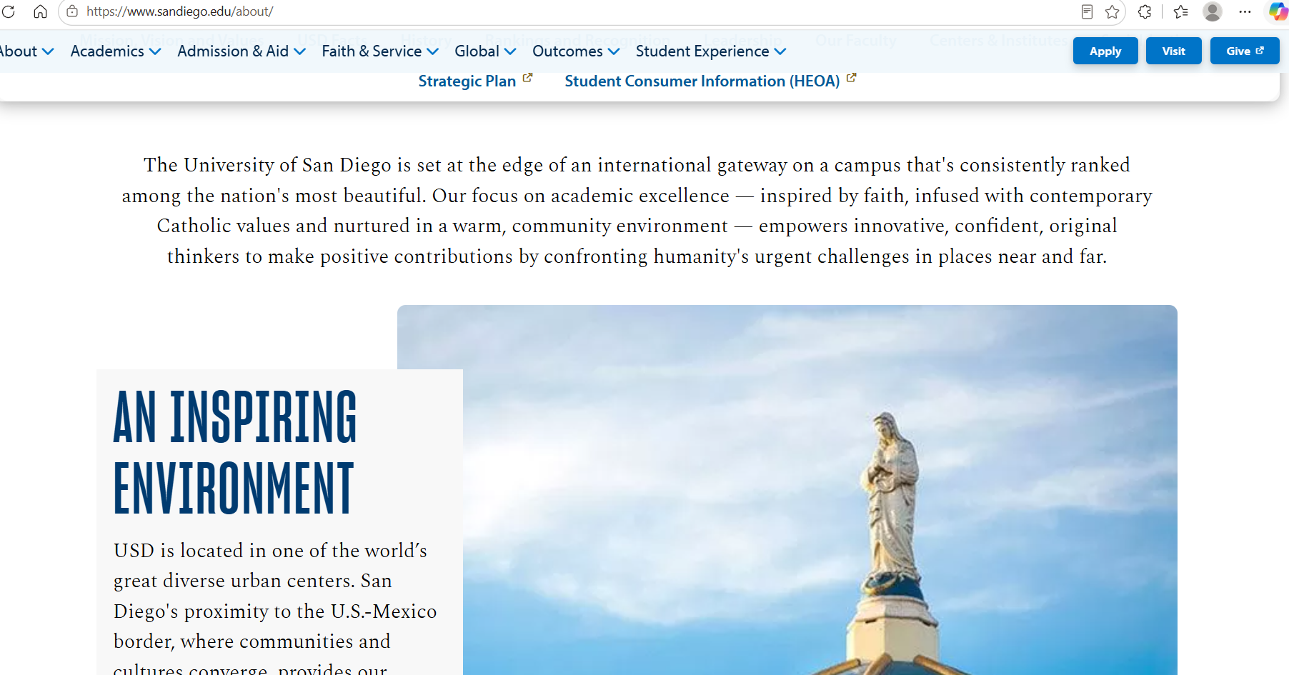
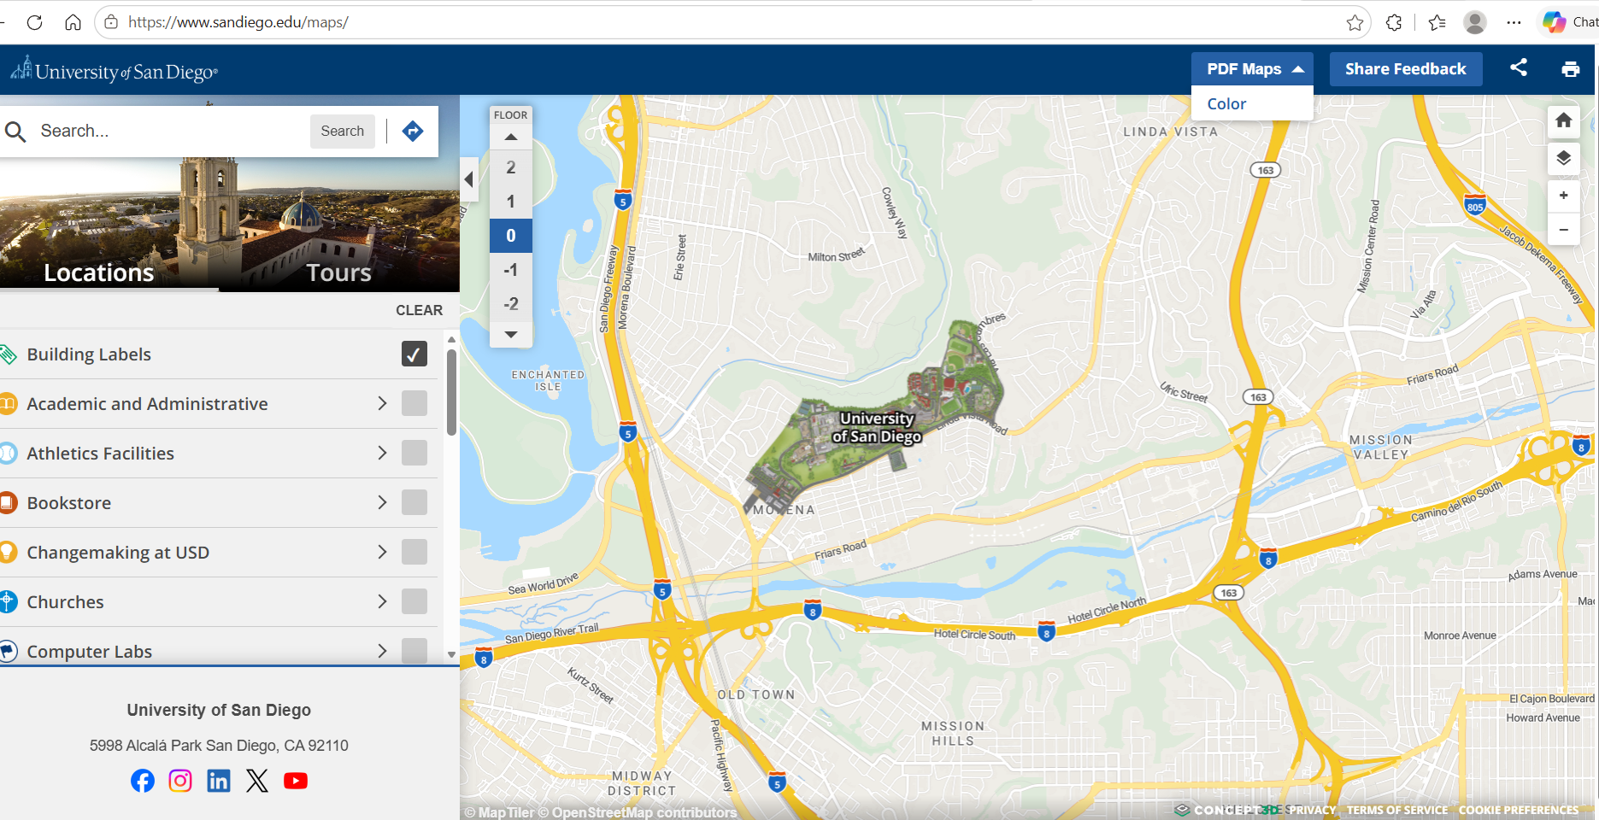
Figure 1. USD address and site map, along with description of what USD is about.

1.2 University Leadership and IT Organization

The University of San Diego’s public leadership directory identifies James T. Harris, DEd, as President and James Antony as Provost and Vice President for Academic Affairs. The captured page also lists Gail F. Baker, PhD, as Counselor to the President; Theresa Byrd, EdD, as Dean, University Library; and Jane Georges, PhD, RN, FAAN, as Dean and Professor. These entries document published leadership titles and business contacts at the time of collection. The screenshot does not establish a complete reporting hierarchy or show every university leadership position.
Name | Title shown | Business email | Phone shown | Location shown
James T. Harris, DEd | President | president@sandiego.edu | (619) 260-4520 | Not shown
James Antony | Provost and Vice President for Academic Affairs | provost@sandiego.edu | Not shown | Not shown
Gail F. Baker, PhD | Counselor to the President | gfbaker@sandiego.edu | Not shown | Not shown
Theresa Byrd, EdD | Dean, University Library | tsbyrd@sandiego.edu | Not shown | CH-001B
Jane Georges, PhD, RN, FAAN | Dean and Professor | nursing@sandiego.edu | (619) 260-4550 | HSN-211


Figure 2. USD public leadership directory showing selected university leaders, published titles, business contacts, and office codes.

The collected Academic Affairs Organizational Chart, dated January 15, 2024, places Gail F. Baker, Senior Vice President and Provost, at the head of the depicted Academic Affairs organization. The chart includes academic schools, administrative functions, and the Chief Information Officer, Elazar Harel. Its connecting lines place the CIO within the organization under the Senior Vice President and Provost.

The CIO branch depicts five functional units: Budget/Admin Services, Customer Support Services, Enterprise Applications, Learning Design Center, and Network Infrastructure. These units are associated with Liza Peterson-Gary, Shahra Meshkaty, Steffanie Hoie, Ashley Kovacs, and Tina Mabe, respectively. This provides documented organizational relationships for the chart’s publication date, rather than relationships inferred solely from staff titles.
Position or functional unit | Person named
Chief Information Officer | Elazar Harel
Budget/Admin Services | Liza Peterson-Gary
Customer Support Services | Shahra Meshkaty
Enterprise Applications | Steffanie Hoie
Learning Design Center | Ashley Kovacs
Network Infrastructure | Tina Mabe

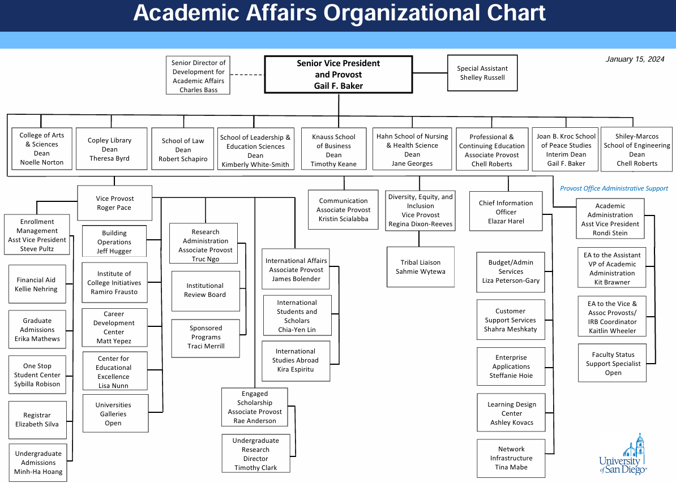
Figure 3. USD Academic Affairs Organizational Chart dated January 15, 2024, showing the Chief Information Officer and associated IT functional units within the depicted Academic Affairs structure.

The University of San Diego’s Information Technology Services staff directory identifies Elazar Harel as Associate Vice President and Chief Information Officer. It also lists senior personnel responsible for enterprise applications, network and infrastructure services, customer support, and budget and administrative services. These published titles describe functional responsibilities, but the directory does not establish a complete reporting hierarchy.

Name | Published title
Elazar Harel | Associate Vice President and Chief Information Officer
Steffanie Hoie | Senior Director of Enterprise Applications
Tina Mabe | Director, Network & Infrastructure Services
Shahra Meshkaty | Senior Director, Customer Support Services
Liza Peterson-Gary | Director, Budget and Administrative Services

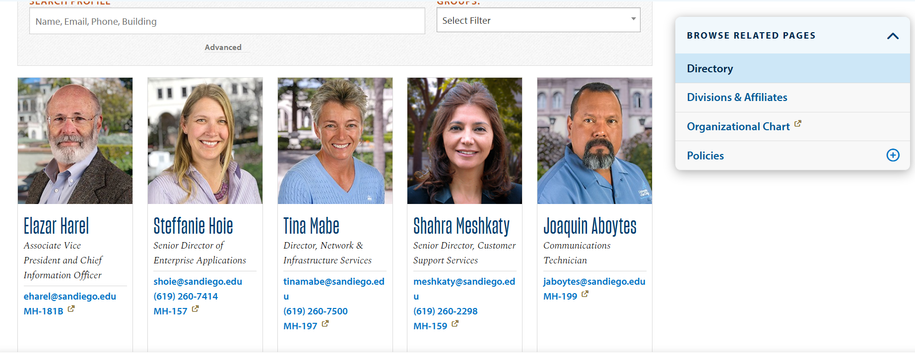
Figure 4. USD IT staff directory.
1.3 Publicly Listed IT Roles and Business Contacts

The directory publishes names, job titles, business contact information, and selected office locations. The following table records representative leadership and technical contacts exactly as shown in the screenshot. “Not shown” means the field was not displayed on that person’s directory card, not that no contact information exists.

Name | Role | Published business email | Published phone | Location shown
Elazar Harel | Associate Vice President and Chief Information Officer | eharel@sandiego.edu | Not shown | MH-181B
Steffanie Hoie | Senior Director of Enterprise Applications | shoie@sandiego.edu | (619) 260-7414 | MH-157
Tina Mabe | Director, Network & Infrastructure Services | tinamabe@sandiego.edu | (619) 260-7500 | MH-197
Shahra Meshkaty | Senior Director, Customer Support Services | meshkaty@sandiego.edu | (619) 260-2298 | MH-159
Amol Athawale | Senior Identity and Access Management Architect | aathawale@sandiego.edu | Not shown | Off Campus
Cesar Fernandez | Senior Network Engineer | cfernandez@sandiego.edu | Not shown | MH-199
Malik Khan | Manager, Systems Services | malikkhan@sandiego.edu | Not shown | Off Campus
Chris Rapp | Associate Director, Enterprise Applications | chris.rapp@sandiego.edu | (619) 260-5939 | MH-157
Michael Vieira | Network Administrator I | mvieira@sandiego.edu | Not shown | MH-199

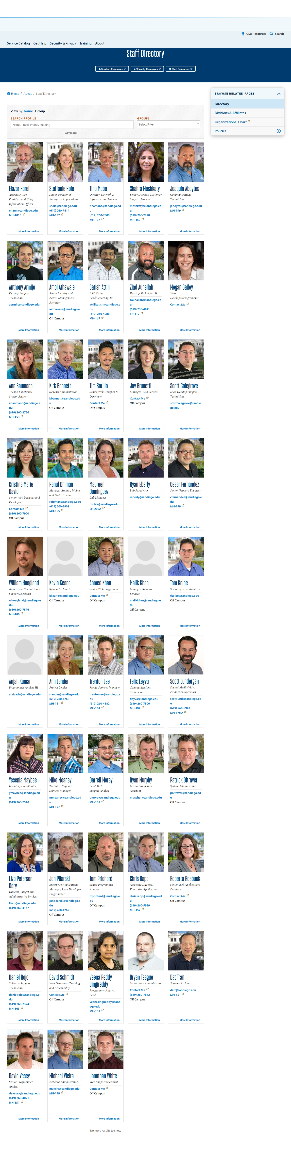
Figure 5. IT staff directory.

1.4 IT Vendors, Partners, and Technologies

The University of San Diego’s public ITS Service Catalog identifies Google Drive as a recommended storage service available to active students, employees, and alumni. This provides direct evidence of Google Drive’s role in USD’s published IT service environment. The page also references USD Policy 2.5.1, stating that personal files not used solely for academic, administrative, or authorized university purposes are prohibited on USD systems. ITS provides resources to help users remove or transfer such files from their USD accounts.

Vendor or technology | Stated use at USD | Source URL | Collection date | Evidence
Google / Google Drive | Recommended storage available to active students, employees, and alumni | https://www.sandiego.edu/its/services/detail/138 | 10/12/26 | Google Drive service-page screenshot

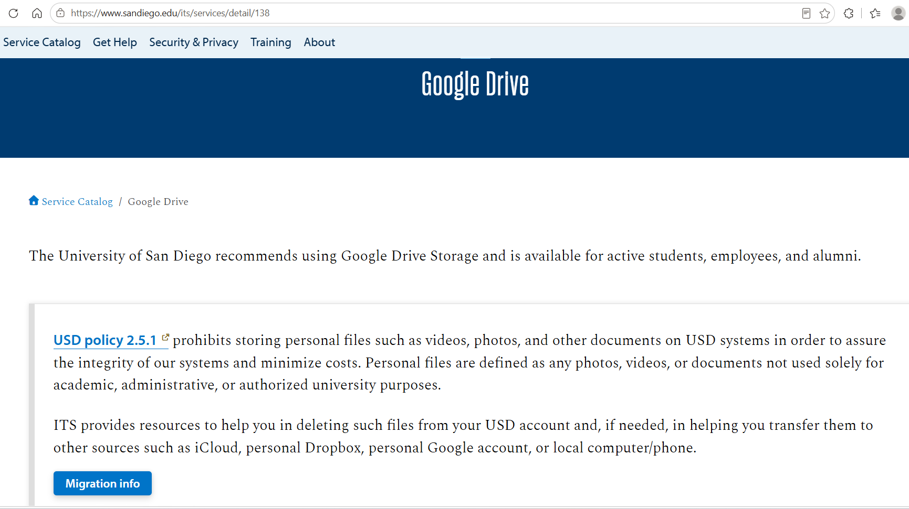
Figure 6. USD’s public ITS Service Catalog.

1.5 Security Relevance and Research Limitations

Public-information research identified university and ITS leadership, published business contacts, campus-location information, and technologies supporting university operations. The ITS service descriptions identify Banner as supporting student biographical, academic, and financial functions, while BDMS/Xtender is described as providing storage and access to student documents. These findings identify business functions relevant to the hypothetical assessment, but do not demonstrate unauthorized access or vulnerabilities.

The Banner service page states that users require authorization from supervisors and data custodians and are restricted to authorized system areas and, in some cases, specific data categories. The catalog also lists multifactor authentication and single sign-on services. These sources document published requirements and available services; they do not independently verify implementation, enforcement, or coverage across applications.

Source dates and scope were considered when interpreting findings. The Academic Affairs organizational chart is dated January 15, 2024, and differs from the separately collected leadership directory. It was therefore treated as historical organizational evidence rather than proof of the current hierarchy. Catalog descriptions were also treated as published service information, not as confirmation of software versions, deployment architecture, or host-to-application mappings.
Key technologies
Technology or service | Use described in the USD catalog
Banner Student Administrative System (INB) | Allows administrative users to enter and maintain student and faculty/advisor-related data.
Banner Student/Faculty Self-Service (SSB) | Provides access to the student administrative system through the MySanDiego portal.
BDMS/Xtender | Saves, stores, and provides online access to student documents.
Canvas (LMS) | Listed as a learning-management service with instructional support available.
Degree Works | Web-based planning tool for students and advisors to monitor progress toward a degree.
Salesforce | Identified as the university’s customer relationship management system.
Workday | Identified as the university’s human resources, payroll, and finance resource supporting business operations.
Cascade Server | Identified as the web content management system for USD academic and departmental websites.
WordPress | USD provides a WordPress solution offering web-based content management.
MySQL | The database entry states that MySQL at USD runs on a separate server and requires a username and password.
Google services | The catalog lists G Suite @ USD, Email/Gmail (ToreroMail), Google Drive, and other Google services.
Microsoft 365 Education | Listed as available for educational use with online-only and online-plus-desktop license options.
Zoom and Zoom Phone | Listed for web videoconferencing and voice calling, respectively.
Panopto | Provides lecture recording, screencasting, video streaming, and video content management.

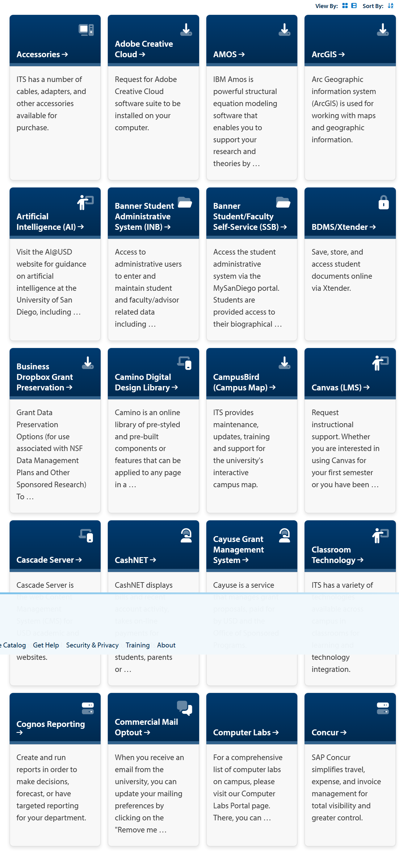
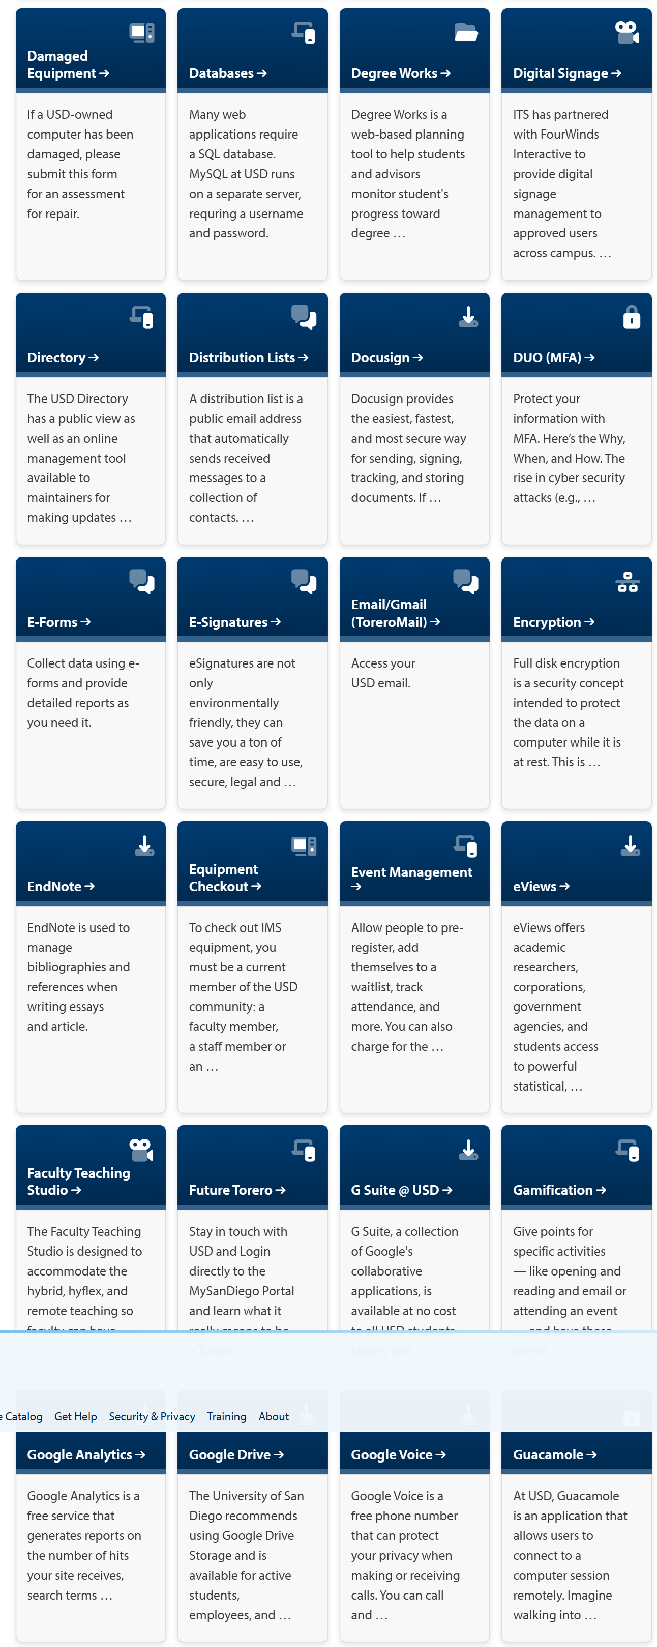
Figure 7. USD technologies and services.
Field | Finding
Technology | Banner Student Administrative System (INB)
Published purpose | Administrative maintenance of student and faculty/advisor-related information
Published restrictions | Supervisor and data-custodian authorization; access limited to authorized system areas and, in some cases, data categories
Source | USD ITS Service Catalog, “Banner Student Administrative System (INB)”
Source URL | https://www.sandiego.edu/its/services/detail/7?&search=&search_relevance=exactAndContains&featured=&view_by=card&item_order=
Collection date/time | 10/12/26 7:00 PM

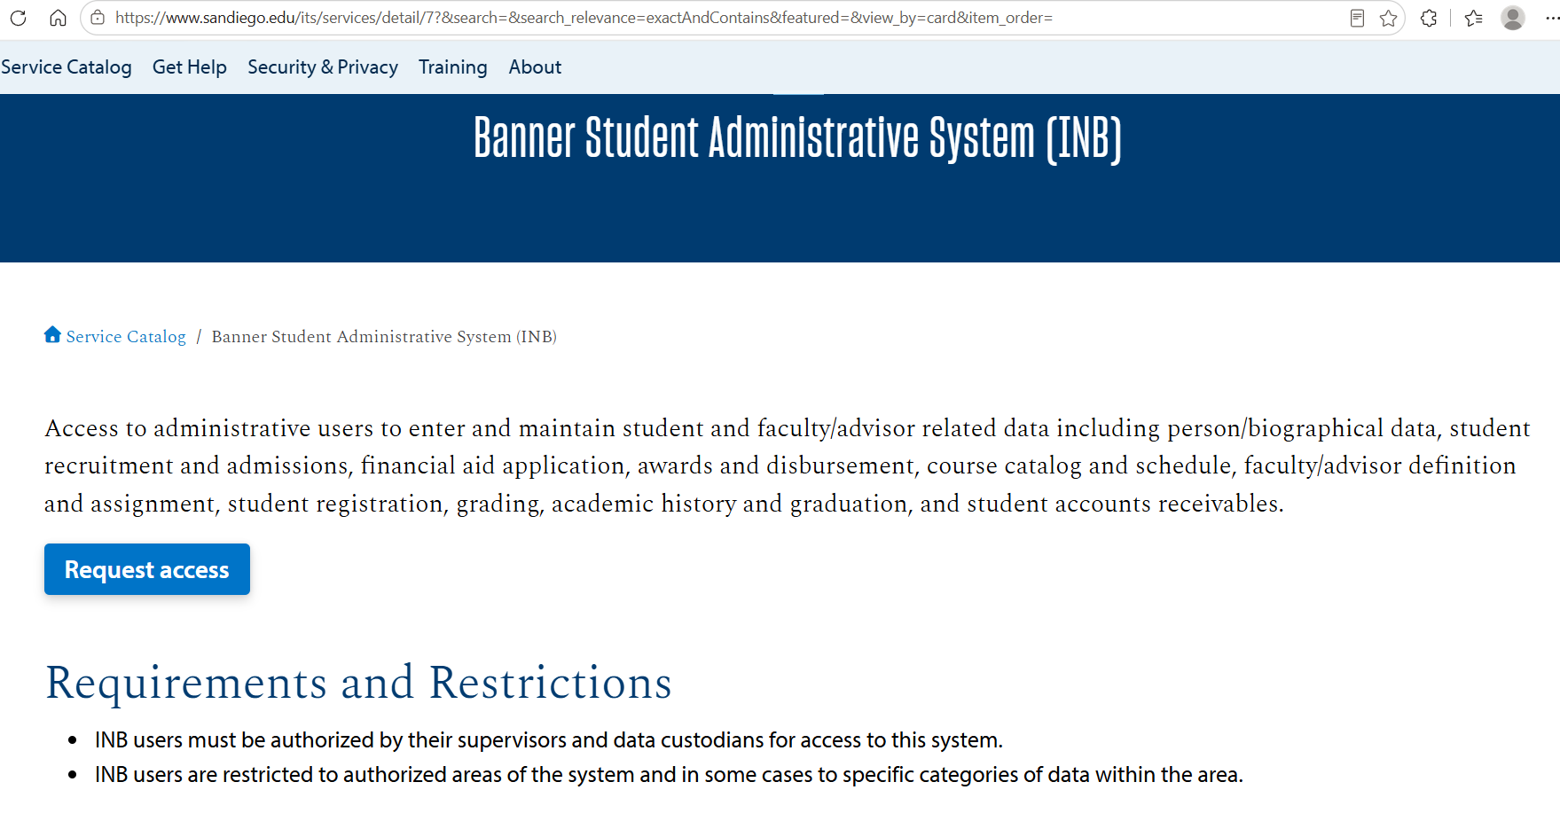
Figure 8. The Banner, BDMS/Xtender, and MySanDiego Portal descriptions identify services associated with student data, documents, and academic records. These findings establish business functions relevant to a hypothetical assessment of student-information protection; they do not establish that records are publicly accessible or that any service is vulnerable. The catalog also documents authentication and remote-access services, but does not show their coverage, configuration, or relationship to individual applications.
- Reconnaissance Tool Report

  - DNS

Purpose

The purpose of this step was to identify the IPv4 address associated with the University of San Diego’s domain, sandiego.edu, using DNSChecker.

Procedure

- Opened the DNSChecker lookup page at https://dnschecker.org/all-dns-records-of-domain.php.

- Entered sandiego.edu in the domain field.

- Selected the A-record lookup option.

- Performed the lookup and recorded the returned information.

Results
Field | Observed result
Domain queried | sandiego.edu
Record type | A
IPv4 address returned | 192.195.155.200
TTL displayed | 300
Owner displayed by DNSChecker | University of San Diego
ASN displayed by DNSChecker | AS14255
Collection date and time | 10/11/2026 8:06 pm

Screenshot
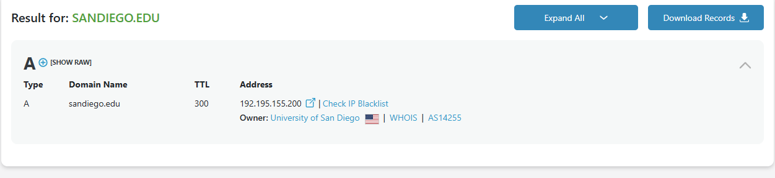
Analysis
The lookup identified 192.195.155.200 as the IPv4 address returned for sandiego.edu at the time of collection. This address will be used in the subsequent ASN and IP-range research in Section 2.1.4. The owner and ASN labels were recorded as preliminary information to be checked during that step. No vulnerability scanning or exploitation was performed as part of this DNS lookup.

  - Whois

The purpose of this step was to retrieve the public registration record for sandiego.edu and identify the domain’s technical contact and authoritative name servers.

Procedure

- Opened a terminal in the Kali Linux VM.

- Executed the following command: whois sandiego.edu

- Reviewed the returned EDUCAUSE Whois record.

- Recorded the technical contact’s name and email address and all listed name servers.

- Captured legible screenshots of the command and relevant output.

Results
Field | Observed result
Domain name | SANDIEGO.EDU
Registrant | University of San Diego
Technical contact | Cesar Fernandez
Technical-contact email | network@sandiego.edu
Technical-contact phone | +1.6192606888
Technical-contact office | Maher Hall, Room 199
Domain record activated | October 20, 2000
Domain record last updated | July 1, 2026
Domain expiration date | July 31, 2027
Collection date and time | 10/11/2026 9:12 pm

The Whois record listed the following authoritative name servers:
NS-39.AWSDNS-04.COM
NS-872.AWSDNS-45.NET
NS-1664.AWSDNS-16.CO.UK
NS-1509.AWSDNS-60.ORG
Screenshot
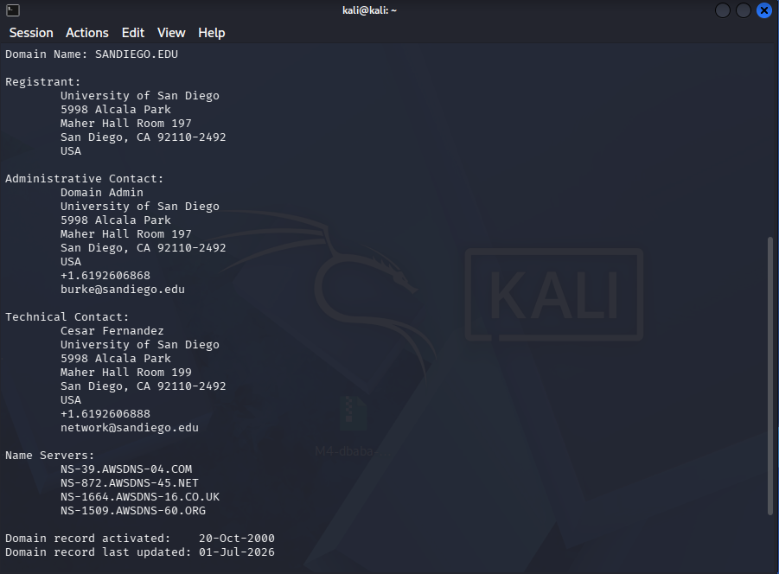
Analysis
The returned Whois record identifies Cesar Fernandez as the domain’s technical contact and provides network@sandiego.edu as the associated email address. It also lists four authoritative name servers. These findings document publicly available domain-registration information; they do not establish the contact’s current system privileges or reveal vulnerabilities in the domain’s infrastructure. No contact with university personnel or vulnerability scanning was performed during this step.
  - ARIN/ASN
Purpose

The purpose of this step was to identify the Autonomous System Number associated with the previously obtained IP address, 192.195.155.200, retrieve its associated network prefixes in CIDR notation, and calculate the number of addresses represented by those prefixes.

Procedure

Opened the HackerTarget Autonomous System Lookup tool.

Entered 192.195.155.200 and performed an IP-to-ASN lookup.

Recorded ASN AS14255, AS name AS-USD, US, and the returned range 192.195.155.0/24.

Entered AS14255 in the same tool and performed an ASN lookup.

Recorded every returned IPv4 and IPv6 prefix.

Calculated address totals, excluding duplicate addresses caused by overlapping prefixes.

Captured screenshots of both lookup results.

Results

The initial IP lookup associated 192.195.155.200 with AS14255 and identified the organization as the University of San Diego. It returned 192.195.155.0/24 as the range containing the queried address.

The subsequent ASN lookup returned the following prefixes.
Prefix returned | Address family | Addresses represented | Counting note
192.55.87.0/24 | IPv4 | 256 | Included
192.195.154.185/32 | IPv4 | 1 | Already contained in 192.195.154.0/24
208.71.27.0/24 | IPv4 | 256 | Included
192.195.153.0/24 | IPv4 | 256 | Included
2607:f380:1::118:9a42:9680/123 | IPv6 | 32 | Counted separately
192.195.155.0/24 | IPv4 | 256 | Included
192.195.154.0/24 | IPv4 | 256 | Includes the separately listed /32
137.164.41.104/31 | IPv4 | 2 | Included
208.71.25.0/24 | IPv4 | 256 | Included

The returned prefixes represent 1,538 unique IPv4 addresses: six /24 networks containing 256 addresses each, plus one /31 containing two addresses. The separately listed 192.195.154.185/32 was not added because it is already included in 192.195.154.0/24. The IPv6 /123 represents 32 IPv6 addresses, reported separately. These counts describe addresses represented by the lookup results, not active hosts.

Screenshots

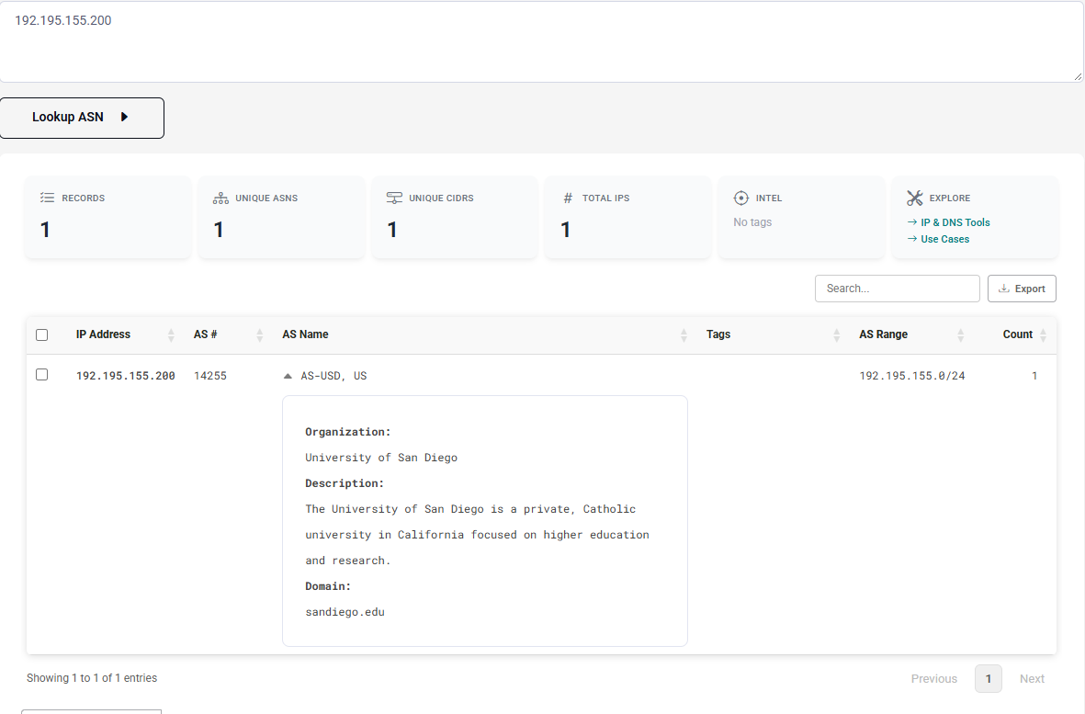
HackerTarget lookup associating 192.195.155.200 with AS14255 and the University of San Diego.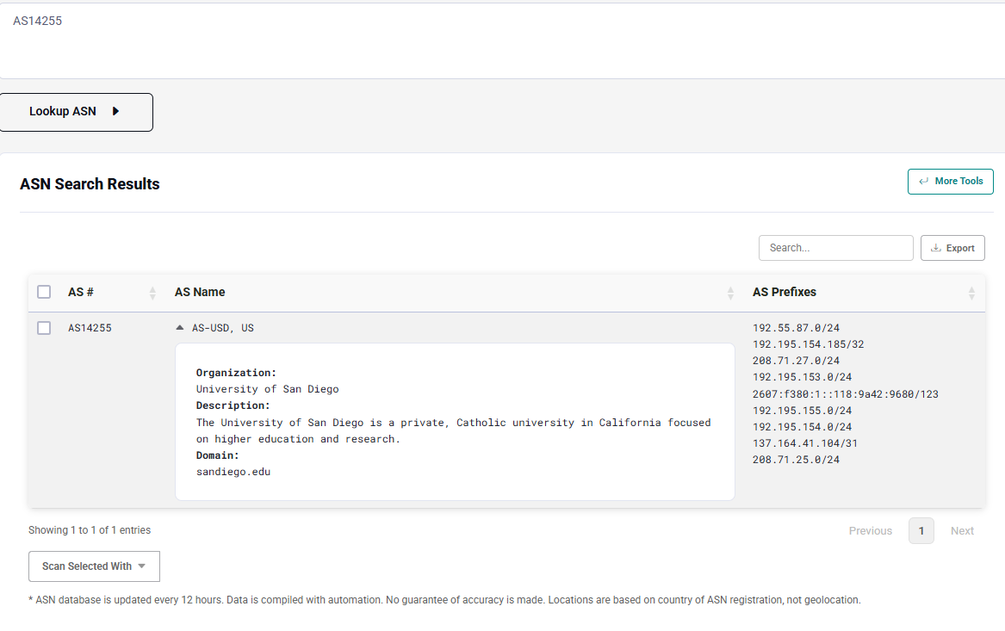
HackerTarget ASN lookup showing the network prefixes associated with AS14255.

Analysis
The results associate the queried website address with AS14255 and show that the ASN lookup returns multiple noncontiguous IPv4 prefixes and an IPv6 prefix. The range containing the website address, 192.195.155.0/24, is therefore only one part of the displayed ASN results. The overlapping /32 entry was excluded from the unique-address total to avoid double-counting.

  - SSL Certificates
Certificate details
Field | Observed result
Certificate viewer hostname | www.sandiego.edu
Subject common name — “Issued to” | www.sandiego.edu
Subject organization | University of San Diego
Subject organizational unit | Not part of certificate
Issuer common name — “Issued by” | InCommon Intermediate CA - OVG3C
Issuer organization | Internet2
Valid from | August 13, 2026, at 10:17:46 PM, as displayed
Expires | February 28, 2027, at 9:17:46 PM, as displayed

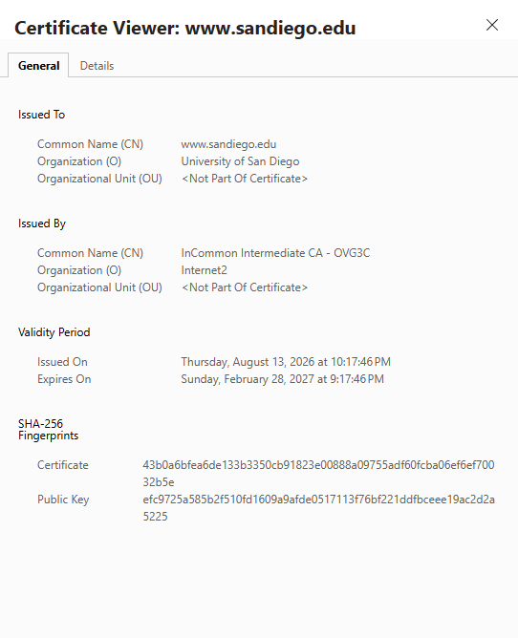
Browser certificate viewer for www.sandiego.edu showing the certificate subject, issuer, and validity period.
No. | DNS name
1 | www.sandiego.edu
2 | mobileprint.sandiego.edu
3 | soles.sandiego.edu
4 | www-real2.sandiego.edu
5 | sandiego.edu
6 | sibc.sandiego.edu
7 | ai.sandiego.edu
8 | nursing.sandiego.edu
9 | charactermatters.sandiego.edu
10 | peace.sandiego.edu
11 | library.sandiego.edu
12 | law.sandiego.edu
13 | bmre.sandiego.edu
14 | web3.sandiego.edu
15 | business.sandiego.edu

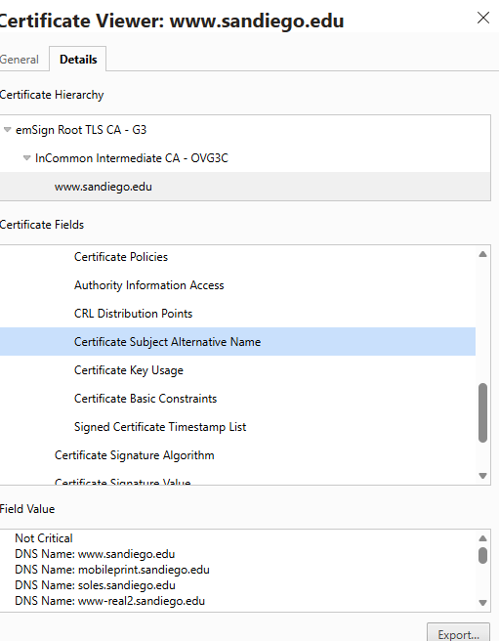
Subject Alternative Name field of the certificate inspected at https://www.sandiego.edu/ , showing 15 DNS names.
The certificate’s signature algorithm was displayed as “X9.62 ECDSA Signature with SHA-384.” The subject public-key algorithm was displayed as “Elliptic Curve Public Key.” The captured public-key field contained hexadecimal key data but did not explicitly identify the key size or named curve. These observations document the certificate’s cryptographic fields; they do not establish which SSL/TLS protocol versions the web server accepts.
Field | Observed result
Certificate signature algorithm | X9.62 ECDSA Signature with SHA-384
Subject public-key algorithm | Elliptic Curve Public Key
Public-key size / named curve | Not explicitly displayed in the captured fields

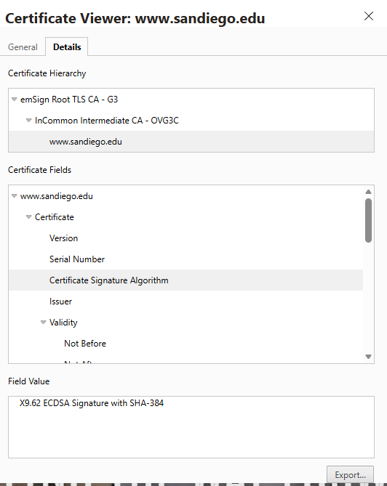
Certificate Details tab showing the ECDSA with SHA-384 signature algorithm.
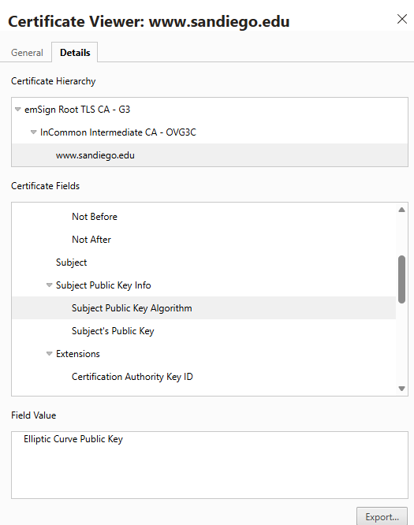
Figure 9. Certificate Details tab showing the elliptic-curve public-key algorithm.
Protocol Support and evidence limitations
Shodan’s indexed result for 192.195.155.200, displaying a certificate issued to www.sandiego.edu, listed TLS 1.2 and TLS 1.3 as supported versions. No obsolete protocol versions were listed in the captured result. This describes Shodan’s recorded observation rather than a new assessment performed by the researcher and does not independently verify the server’s current configuration. The finding applies to the observed service, not necessarily to every USD hostname or server.

The certificate’s signature and public-key algorithms were recorded separately from protocol-support evidence. Those certificate fields do not establish which SSL/TLS versions the server accepts. Therefore, the appropriate conclusion is that no obsolete protocols were shown in the collected Shodan evidence—not that obsolete protocols were conclusively disabled across USD’s environment.
Security Implications of Obsolete Protocols
TLS 1.0 and TLS 1.1 were formally deprecated by RFC 8996, which states that they must not be used or negotiated. These older versions lack support for current recommended cryptographic algorithms and mechanisms. SSL 3.0 was also deprecated because it is not sufficiently secure, and RFC 7568 prohibits its use and negotiation.

If a server accepts obsolete protocols, it permits connections using security mechanisms that no longer meet current recommendations. Keeping these options available increases the attack surface and creates additional opportunities for misconfiguration, even when newer protocol versions are also supported. The specific risk depends on the protocol, cipher suites, implementation, and client behavior; acceptance of an obsolete version alone does not prove that information has been compromised.

For services handling credentials or student information, an authorized follow-up assessment should verify the accepted protocol versions and cryptographic configuration. If obsolete versions are confirmed, they should be disabled in favor of appropriately configured TLS 1.2 and TLS 1.3. This is a proposed validation step for a real, authorized engagement, not an additional test conducted against USD for this assignment.
  - Shodan

Purpose

The purpose of this step was to examine Shodan’s indexed observations of internet-accessible services associated with sandiego.edu and the selected subnet, 192.195.155.0/24. The research aimed to record displayed result counts, identify observed ports and services, examine Microsoft IIS versions and certificate common names, and review indicators of potentially unsupported software. Shodan was used as an existing source of reconnaissance data; its results were not treated as proof of current service availability, distinct host counts, or confirmed vulnerabilities.

Procedure

Logged into Shodan and entered the following query:

hostname:sandiego.edu

Recorded the displayed result count and captured a screenshot of the search results.

Results
Field | Observed result
Search query | hostname:sandiego.edu
Total results displayed | 186
Collection date and time | 10/11/26 11:51 pm

Shodan displayed 186 results for the query hostname:sandiego.edu at the time of collection. This value is reported as the displayed search-result count; a count of distinct IP addresses was not independently established.

Screenshots

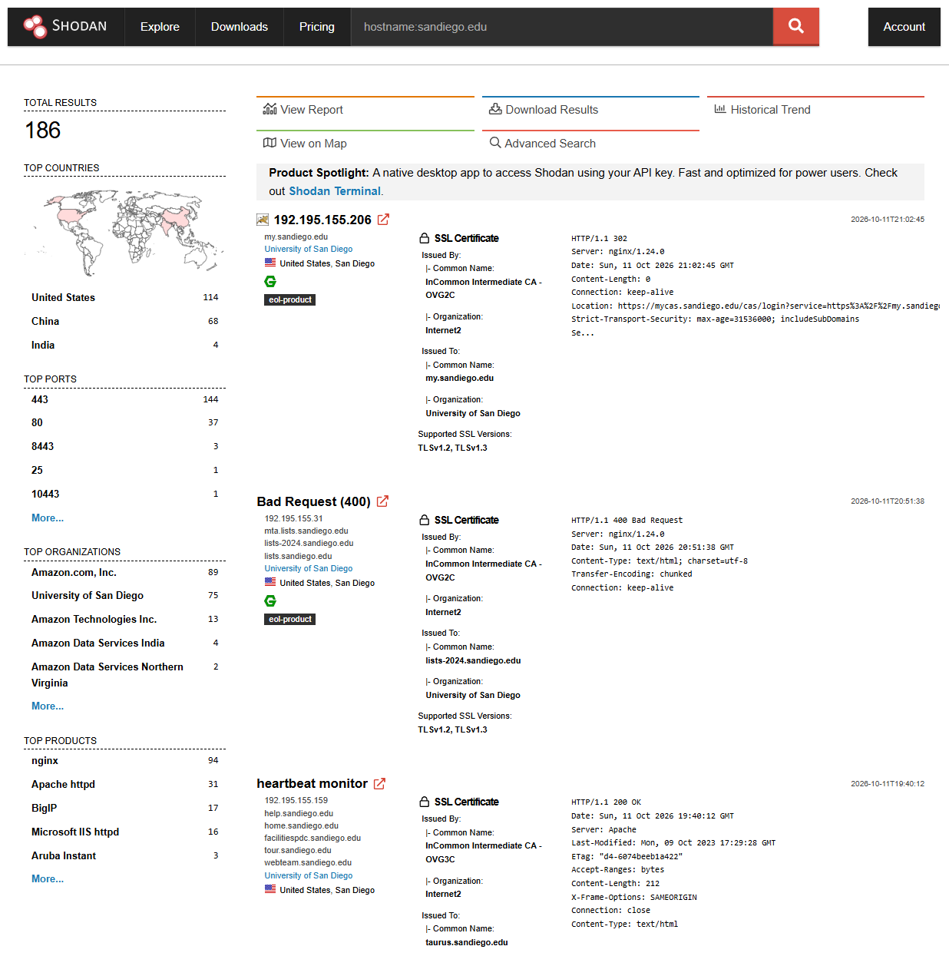
Shodan hostname search for sandiego.edu showing 186 total results.
Procedure
Entered the following query in Shodan to search indexed results within the subnet containing the previously identified website address: net:192.195.155.0/24

Results
Field | Observed result
Search query | net:192.195.155.0/24
Subnet examined | 192.195.155.0/24
Total results displayed | 71
Collection date and time | 10/12/26 12:01 AM

Shodan displayed 71 results for the subnet query net:192.195.155.0/24. This is the displayed search-result count; distinct IP addresses were not independently counted. The query covers this specific subnet, not all prefixes associated with AS14255.

Screenshots
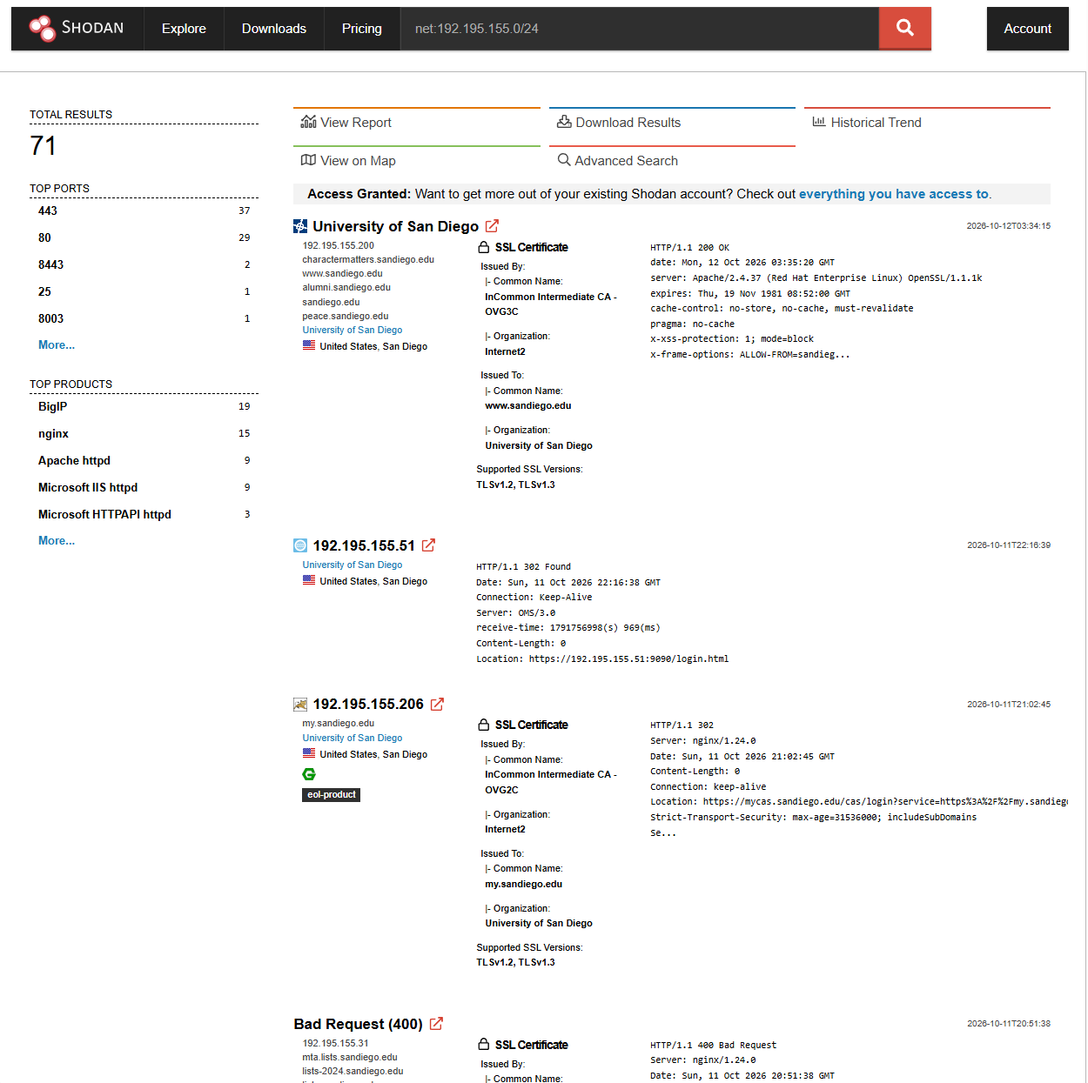
Shodan subnet search for 192.195.155.0/24 showing 71 total results.
Port | Shodan result count | Service identification
443 | 37 | HTTP responses with certificates; one result advertises nginx 1.26.3.
80 | 29 | Visible banners include HTTP responses and headers advertising BigIP, Microsoft IIS, and Microsoft HTTPAPI. Shodan’s product summary also lists nginx and Apache httpd.
8443 | 2 | HTTP responses and certificate information shown for both results; one advertises nginx 1.26.3, while the other does not identify its server software.
25 | 1 | 192.195.155.236 returned a Postfix greeting and advertised STARTTLS; software version not shown.
8003 | 1 | 192.195.155.34 returned HTTP/1.1 404 ERROR; server software and version were not identified in the displayed banner.
8090 | 1 | 192.195.155.51 returned an HTTP 302 redirect to an HTTPS login URL on port 9090. The underlying product was not independently verified.

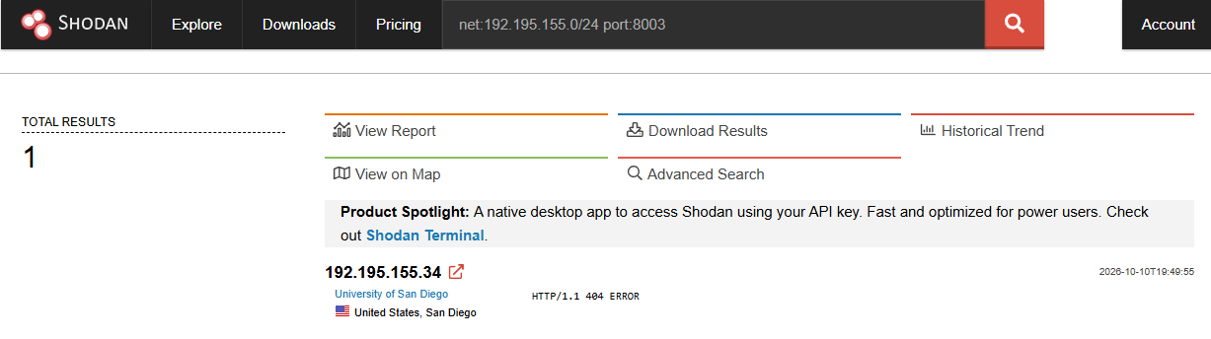
Port 8003
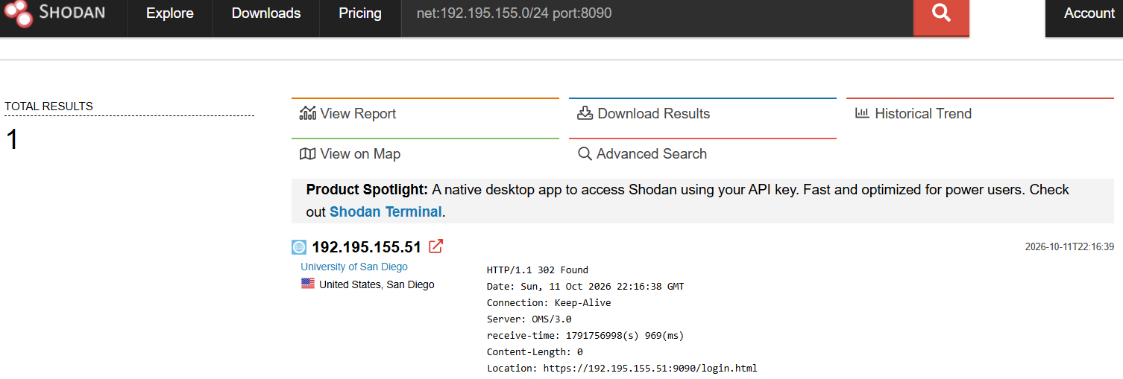
Port 8090
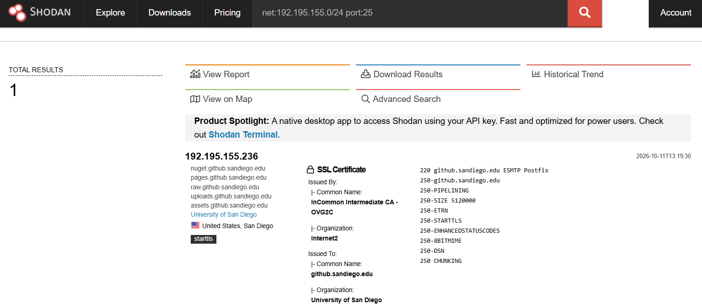
Port 25
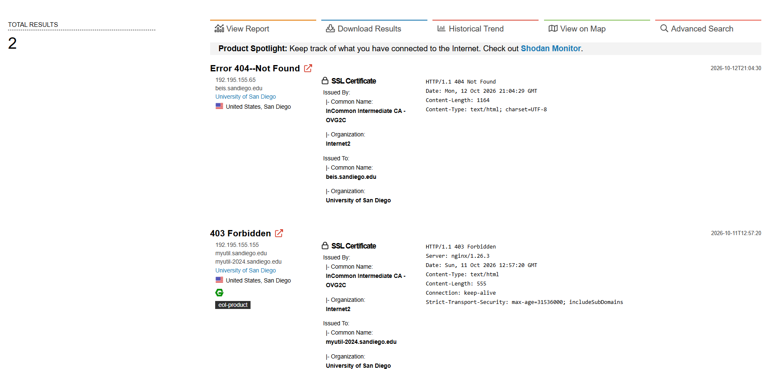
Port 8443
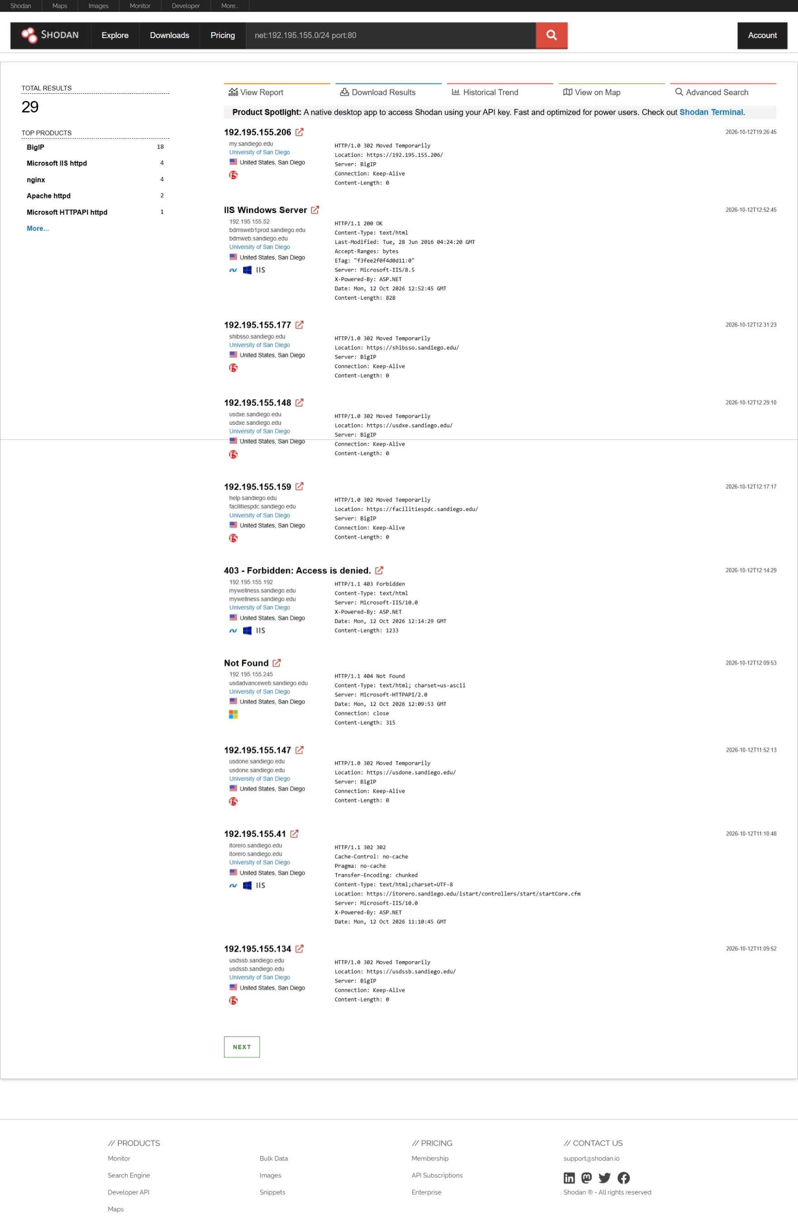
Port 80
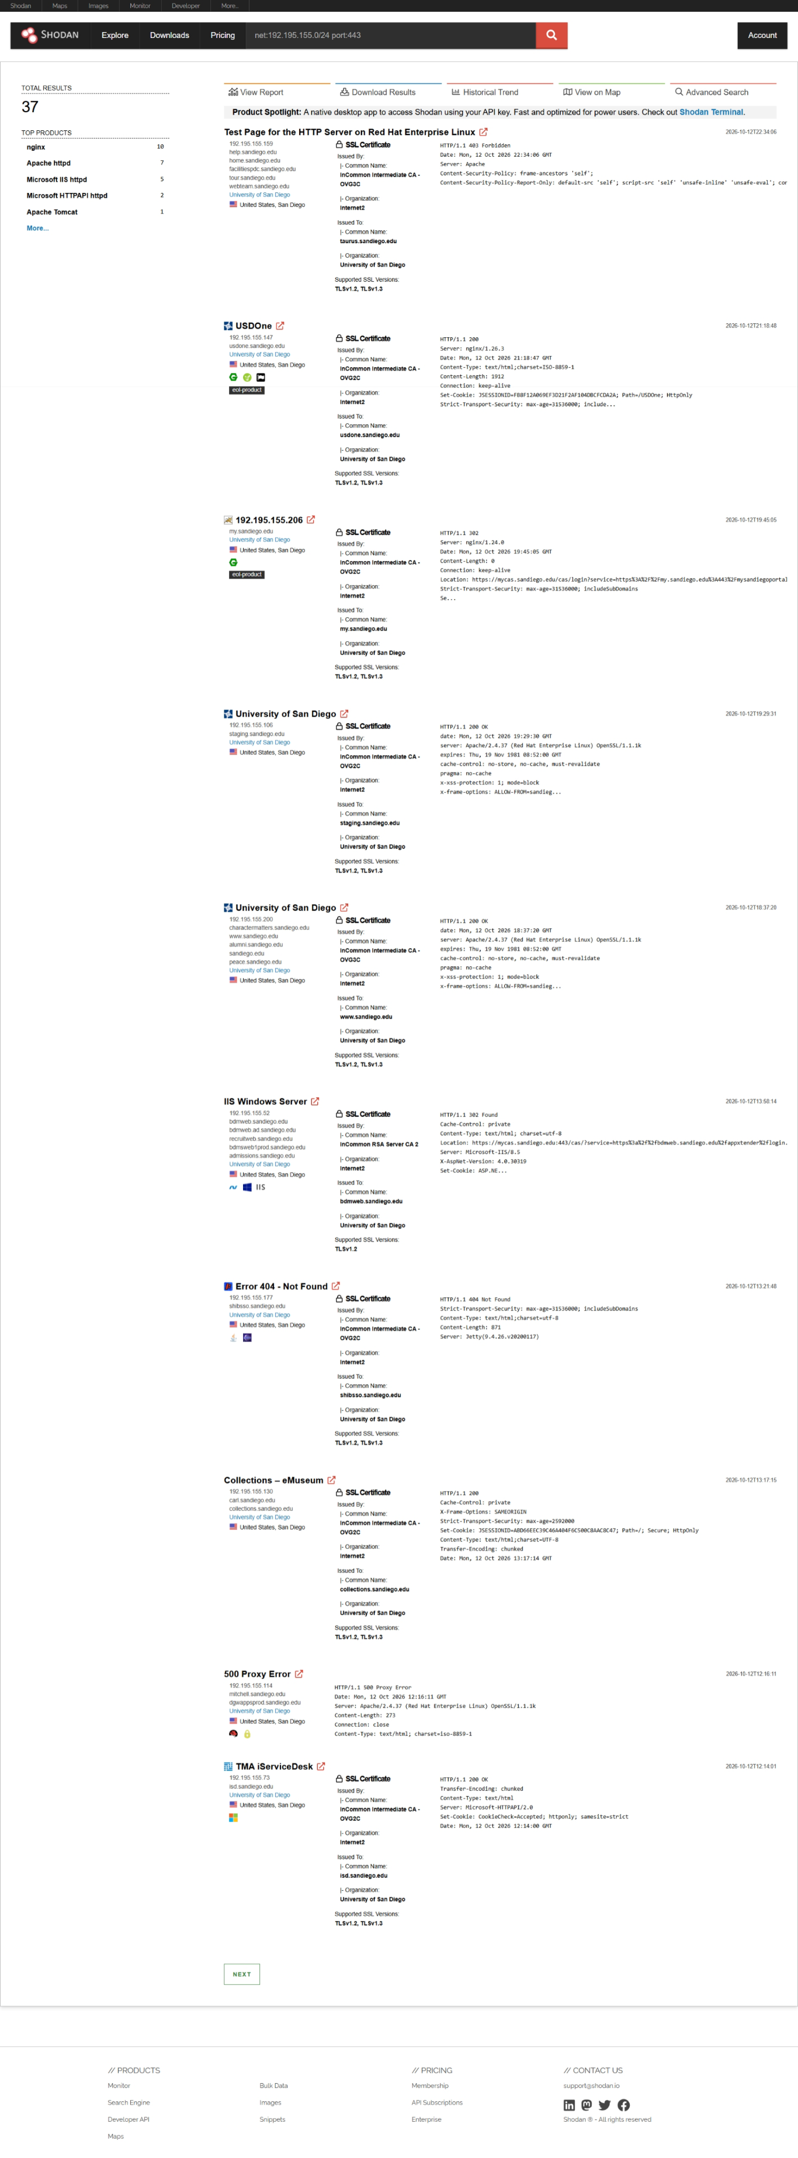
Port 443
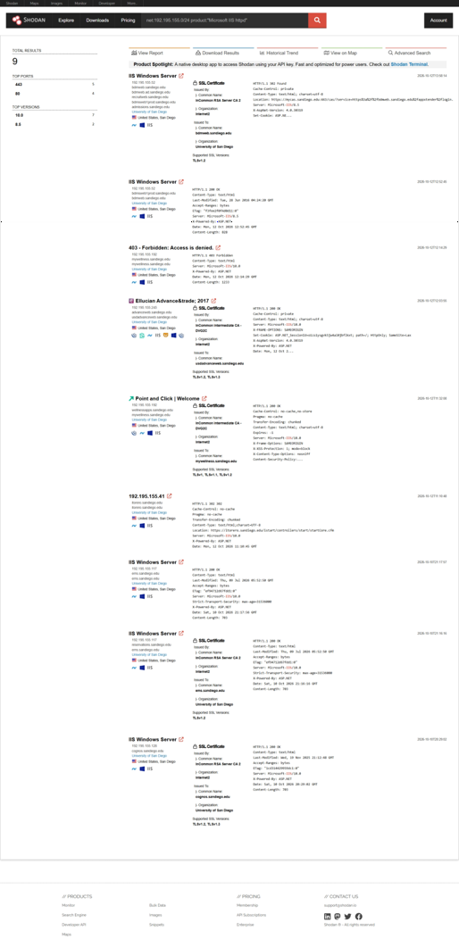
Shodan IIS search within 192.195.155.0/24 showing nine service results, version counts, and six distinct IP addresses.
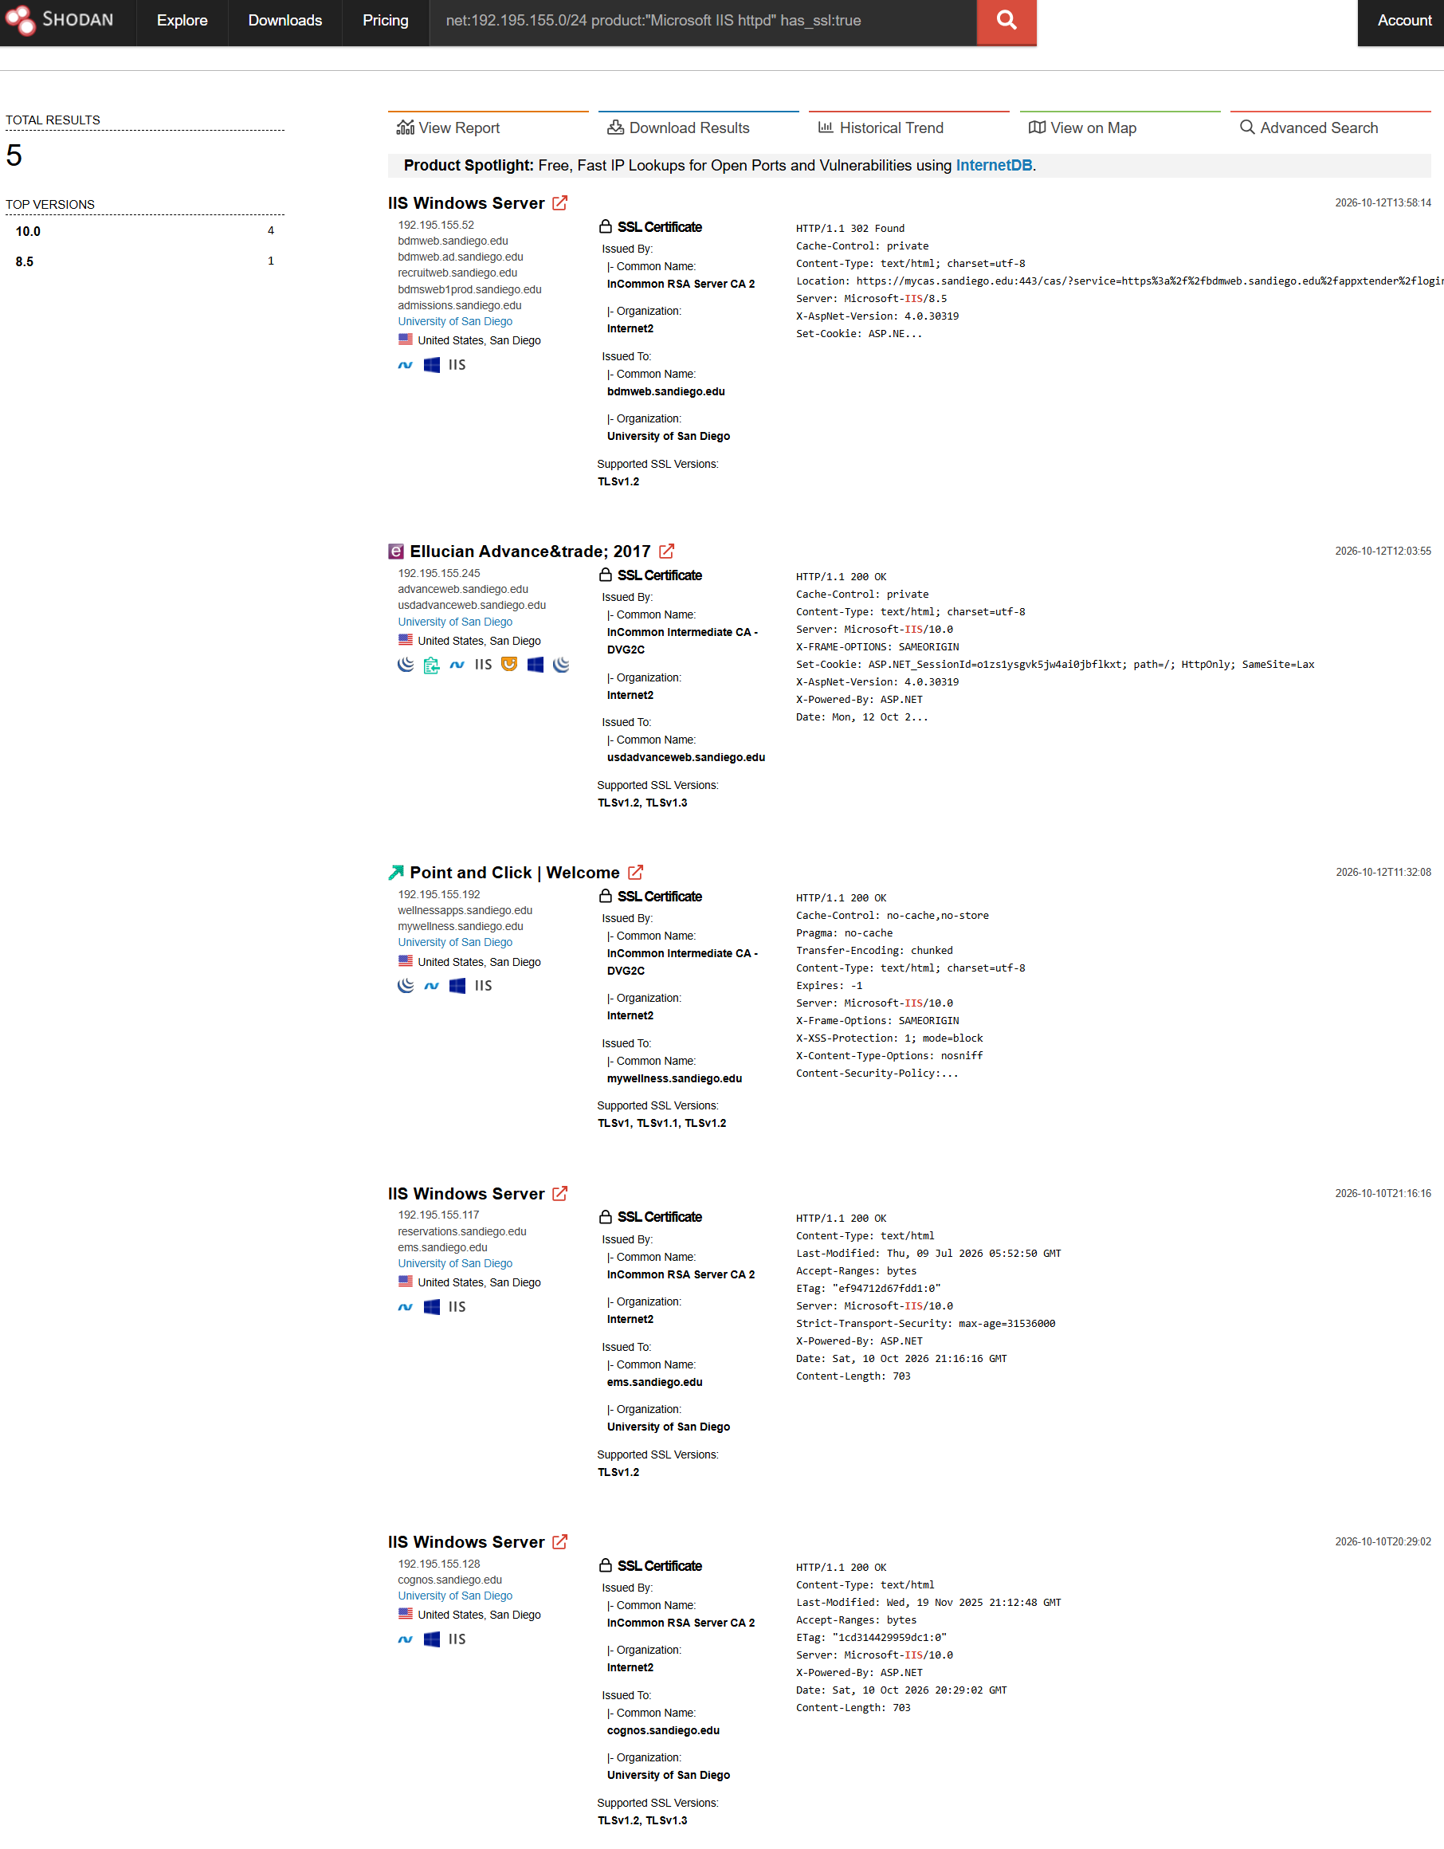
Shodan query filtering IIS results with SSL certificate information within 192.195.155.0/24, showing five results and their certificate common names.
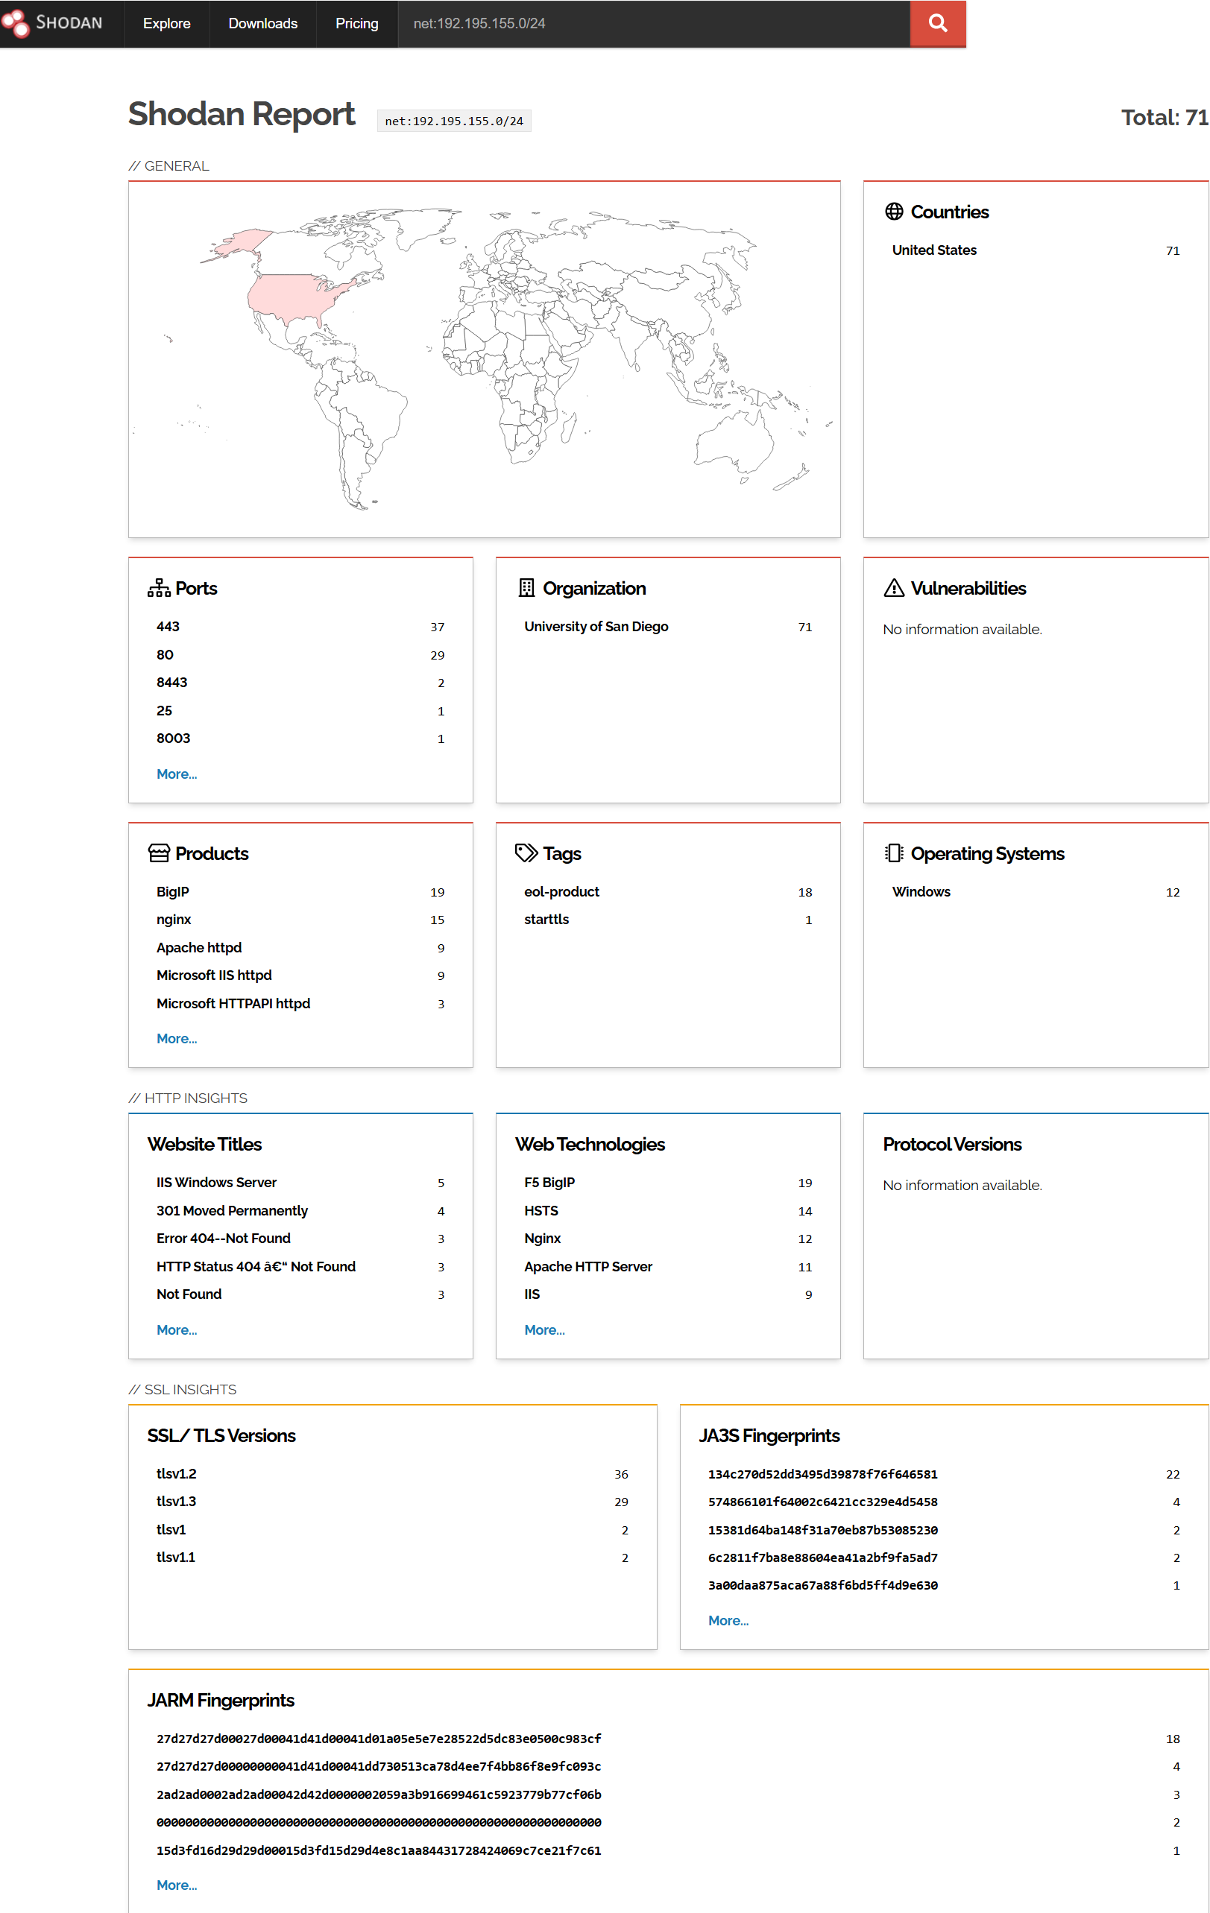
Shodan subnet report for 192.195.155.0/24 showing General, HTTP Insights, and SSL Insights categories.
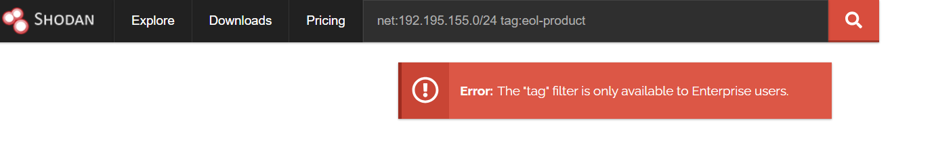
Shodan’s subnet report displayed 18 results with the eol-product tag. An attempt to isolate those results using net:192.195.155.0/24 tag:eol-product was unsuccessful because Shodan restricted the tag filter to Enterprise accounts. Consequently, the flagged results could not all be enumerated through that filter. Individual flagged records visible in the ordinary search results were retained for further analysis.
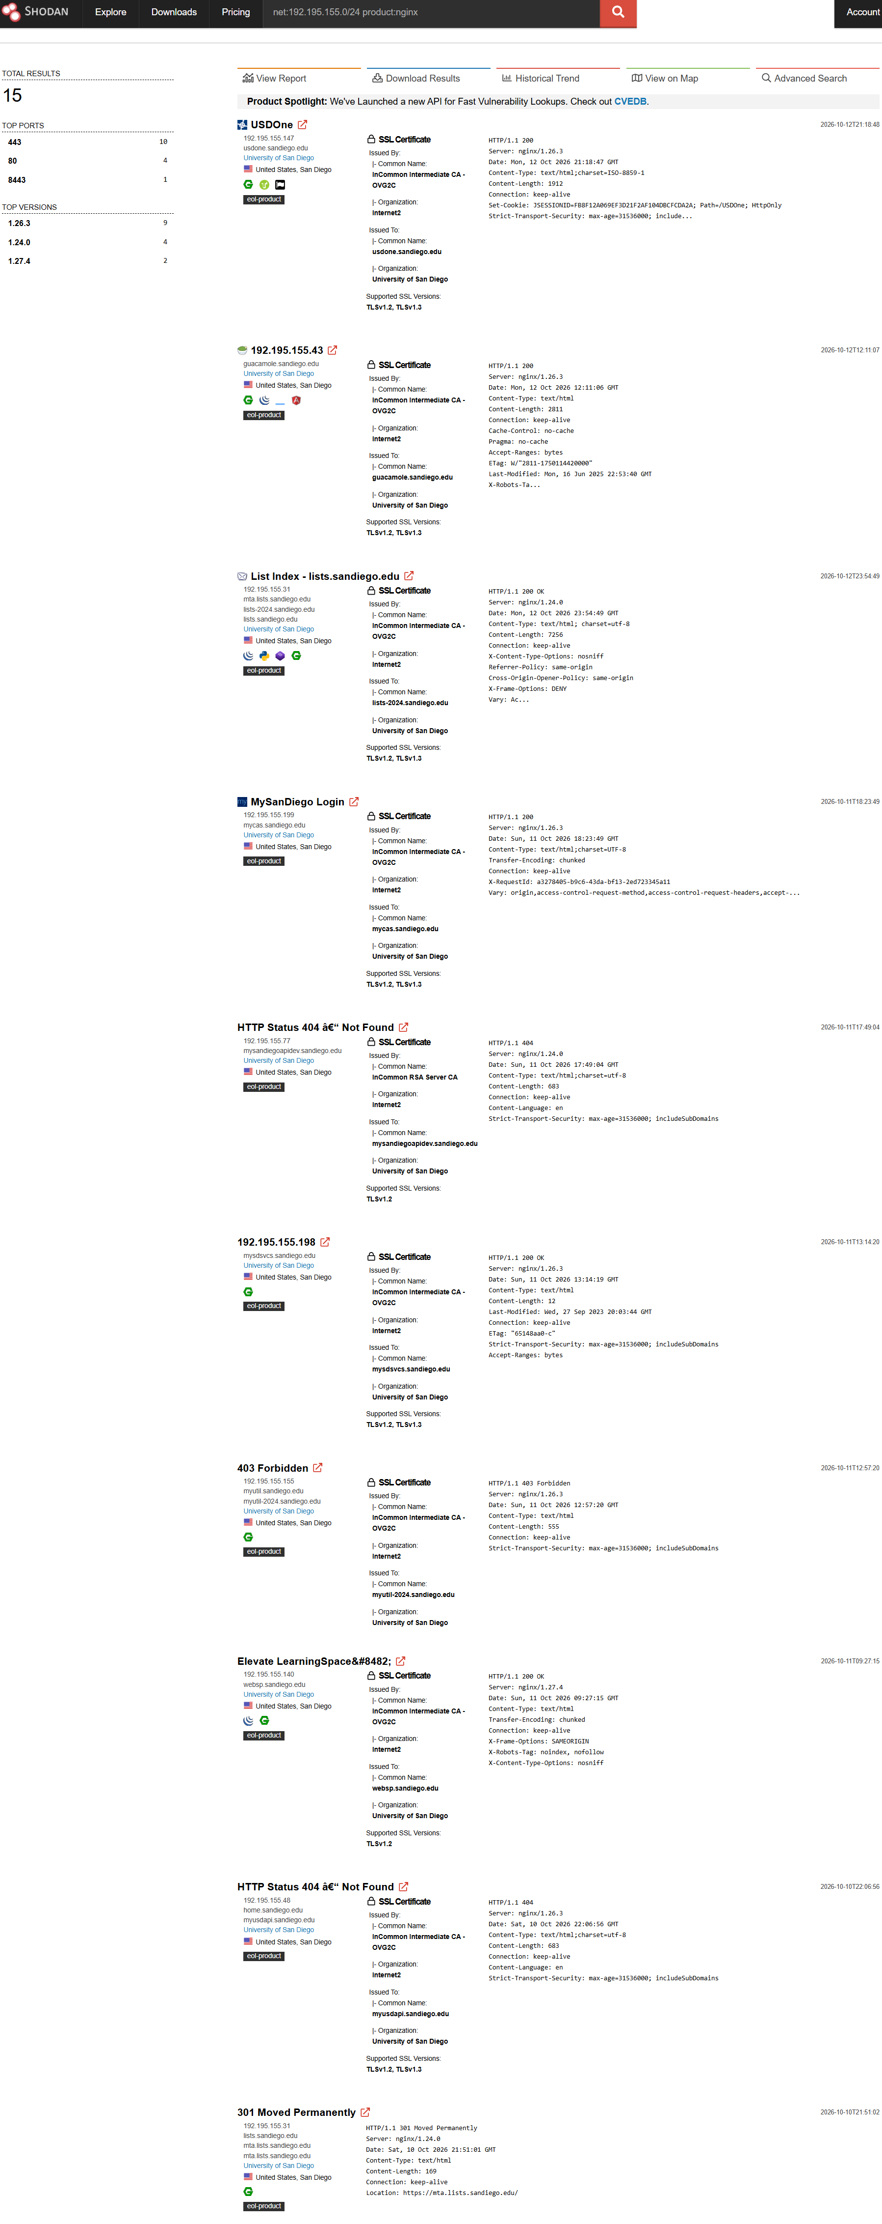
Shodan nginx search within 192.195.155.0/24 showing 15 service results, advertised versions, and visible end-of-life product indicators.

From the results for net:192.195.155.0/24, selected “More…” beneath Top Ports to open Shodan’s port facet analysis. The expanded analysis listed six ports: 443, 80, 8443, 25, 8003, and 8090. The corresponding result counts were 37, 29, 2, 1, 1, and 1, respectively, totaling 71 indexed results. These counts describe Shodan’s recorded results, not independently verified current services or distinct hosts.
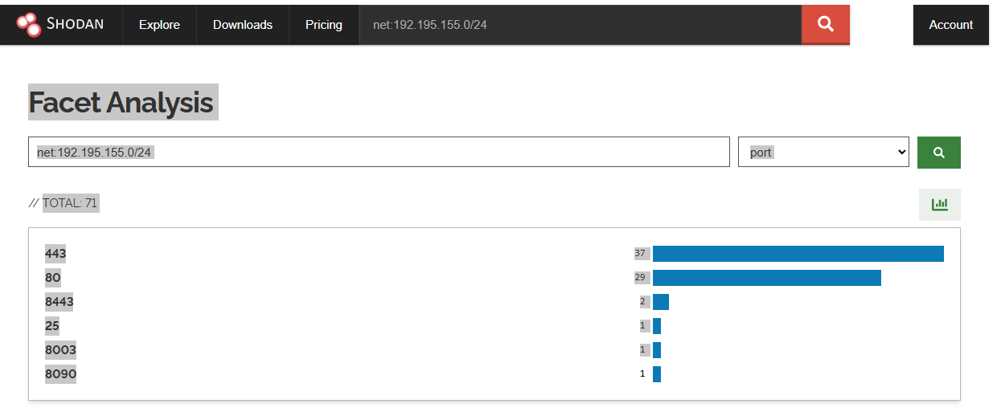
Shodan port facet analysis for 192.195.155.0/24 showing six indexed ports and their result counts.
Shodan reported 18 results tagged eol-product; this is an indexed classification, not an independently verified count of unsupported hosts. The available account could not isolate all tagged records, so only individually visible product/version observations were available for further verification.
  - Fierce

Purpose
The purpose of this step was to enumerate publicly resolvable hostnames within sandiego.edu, record their associated IP addresses, examine nearby reverse-DNS results, and identify evidence of third-party hosting providers.

Procedure
- Executed the following command in the Kali Linux VM:
- fierce --domain sandiego.edu
- Performed the test from Kali Linux VM using my home internet connection, outside USD’s network and without an active USD VPN.
- Retained the complete command output and captured legible screenshots.
- Recorded entries labeled “Found” separately from the hostname/IP mappings displayed under “Nearby.”

- Counted directly found hostnames, distinct directly found IP addresses, and nearby hostname/IP pairs.
- Examined provider-related DNS names without assuming that neighboring addresses belonged to USD.
Results
Measure | Count
Directly found hostnames | 37
Unique IP addresses among direct findings | 28
“Nearby” blocks | 22
Nearby hostname/IP pairs | 158
Unique IP addresses in nearby results | 158

Direct findings:
Hostname | IP address
access.sandiego.edu | 192.195.155.83
ai.sandiego.edu | 192.195.155.200
arizona.sandiego.edu | 54.193.22.52
blue.sandiego.edu | 52.37.118.199
build.sandiego.edu | 192.195.155.226
business.sandiego.edu | 192.195.155.200
catalog.sandiego.edu | 3.146.247.8
cms.sandiego.edu | 52.37.118.199
digital.sandiego.edu | 203.22.241.43
docs.sandiego.edu | 192.178.164.121
downloads.sandiego.edu | 192.195.155.39
email.sandiego.edu | 34.102.239.211
files.sandiego.edu | 192.195.155.233
flash.sandiego.edu | 192.195.155.136
ftp.sandiego.edu | 192.195.155.251
gallery.sandiego.edu | 52.37.118.199
gamma.sandiego.edu | 192.195.155.252
gatekeeper.sandiego.edu | 192.195.155.146
gmail.sandiego.edu | 192.178.164.153
go.sandiego.edu | 141.193.213.20
help.sandiego.edu | 192.195.155.159
home.sandiego.edu | 192.195.155.159
india.sandiego.edu | 104.16.150.108
jobs.sandiego.edu | 18.65.3.50
ldap.sandiego.edu | 192.195.155.29
lib.sandiego.edu | 192.195.155.21
library.sandiego.edu | 192.195.155.200
lists.sandiego.edu | 192.195.155.31
m.sandiego.edu | 184.106.85.159
mail.sandiego.edu | 192.195.154.123
maps.sandiego.edu | 52.37.118.199
marketing.sandiego.edu | 34.215.216.138
med.sandiego.edu | 141.193.213.20
mesh.sandiego.edu | 141.193.213.20
mississippi.sandiego.edu | 54.193.77.125
my.sandiego.edu | 192.195.155.206
online.sandiego.edu | 141.193.213.20

Nearby results
Direct finding preceding the nearby block | Nearby pairs
access | 4
ai | 6
arizona | 11
blue | 11
build | 10
catalog | 11
docs | 11
downloads | 7
email | 11
files | 4
flash | 5
ftp | 3
gatekeeper | 4
gmail | 11
help | 4
jobs | 11
ldap | 4
lib | 3
m | 2
marketing | 11
mississippi | 11
my | 3
Total | 158

Cloud-Provider Evidence

The results indicated use of infrastructure associated with AWS and Google. Addresses returned for several USD hostnames had AWS-style compute.amazonaws.com reverse names. The address for jobs.sandiego.edu had a cloudfront.net reverse name, consistent with Amazon CloudFront infrastructure. AWS documentation identifies cloudfront.net names as CloudFront distribution names.
The addresses returned for docs.sandiego.edu and gmail.sandiego.edu had reverse names ending in 1e100.net. Google identifies this as a Google-owned domain used for servers in its network. This supports attribution to Google infrastructure, but does not by itself establish the exact service or contractual relationship.

Analysis and limitations

Multiple hostnames resolved to shared addresses, like blue, cms, gallery, and maps resolved to 52.37.118.199. Therefore, hostname counts were distinguished from unique-IP counts.

Nearby reverse-DNS results included university names, provider-generated names, and unrelated domains. Address proximity alone does not establish USD ownership, management, or authorization for testing. Some direct and nearby counts were not added together.

Fierce displayed Zone: failure and Wildcard: failure. These messages were retained as tool output but were not treated as evidence that the DNS infrastructure was vulnerable. The findings describe DNS observation at the time of collection, not confirmed listening services or a complete asset inventory.

Screenshots
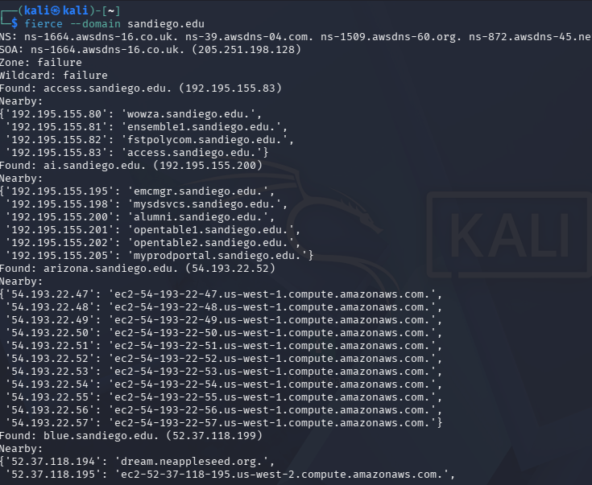
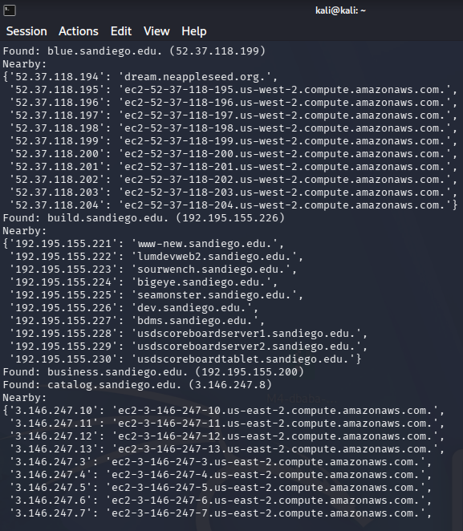
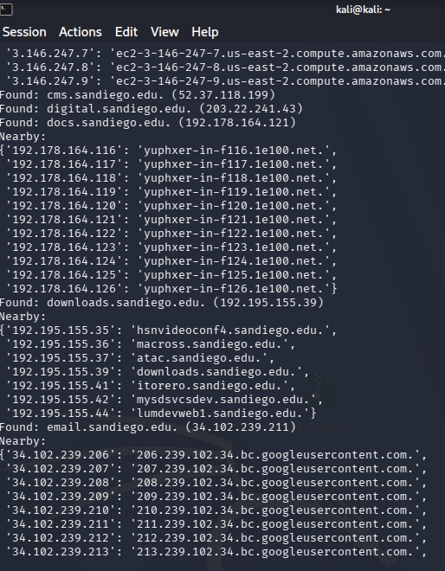
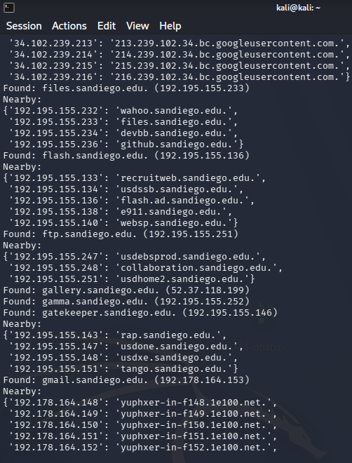
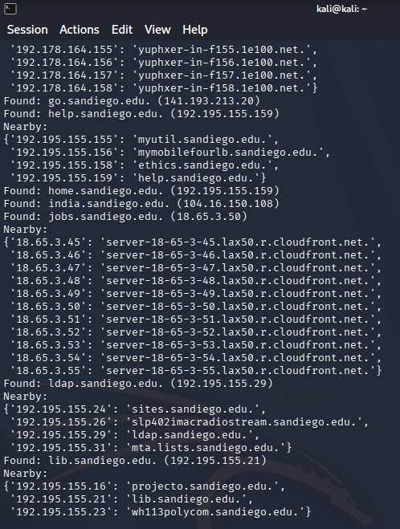
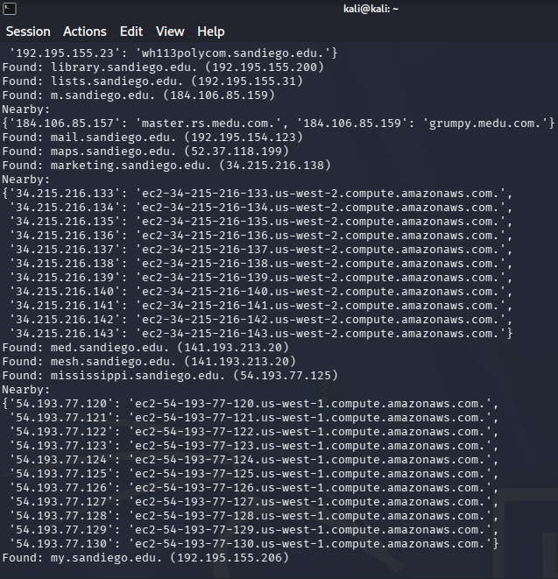
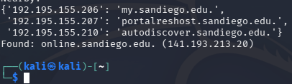
Fierce DNS enumeration of sandiego.edu showing directly found hostnames and nearby reverse-DNS mappings.
3. Recommendations for the Next Phase
3.1 Authorization and Scope
Before proceeding with a real penetration test, written authorization and rules of engagement should define the approved systems, network ranges, applications, testing windows, permitted techniques, emergency contacts, and stopping conditions. The objective would be to determine whether an external attacker could obtain unauthorized access to protected student information while minimizing disruption and avoiding unnecessary exposure of actual student records. NIST SP 800-115 identifies assessment planning, authorization, and sensitive-data handling as important components of security testing.
The scope should distinguish university-controlled assets from third-party infrastructure. Fierce returned university hostnames associated with multiple address ranges and provider-related DNS names, but neighboring addresses and shared hosting infrastructure should not automatically be included. University and provider permissions should be confirmed before testing any externally hosted service.
These recommendations are hypothetical. No additional production-system scanning, exploitation, or staff contact is proposed as part of this assignment. Subsequent hands-on enumeration, scanning, and exploitation will be performed only against the designated Metasploitable2 laboratory target.
3.2 Student-Information Systems and Access Controls
The first application-level priority should be to establish which systems store, process, or provide access to protected student information. The public Banner description identifies functions involving biographical information, admissions, financial aid, registration, grading, academic history, and student accounts. The ITS catalog also describes BDMS/Xtender as providing storage and online access to student documents and the MySanDiego Portal as supporting access to academic records and registration functions. These services are relevant because of their documented business functions, not because a vulnerability has been established.
After confirming application ownership and scope, an authorized assessment should evaluate:
- Whether access approvals reflect the published supervisor and data-custodian requirements.
- Whether student, faculty/advisor, and administrative roles are restricted to their intended information and functions.
- Whether access is removed when users leave the university or change responsibilities.
- Whether applicable multifactor authentication and single sign-on controls cover the approved applications.
- Whether access to sensitive information is logged and available for investigation.
These proposed checks follow from Banner’s published authorization restrictions and the catalog’s authentication-service listings. The public sources do not establish how those controls are implemented or whether they are effective.
Testing should use university-provided test accounts and synthetic student records wherever possible. If actual protected information is encountered, the assessors should follow the agreed stopping, notification, and evidence-handling procedures rather than collecting additional records to demonstrate impact.
3.3 Evidence-Based Host and Service Prioritization
The reconnaissance results should be reconciled with an owner-approved asset inventory before vulnerability assessment begins. Shodan records and DNS mappings provide useful leads, but they do not independently establish current service availability, asset ownership, or application purpose. The following candidates warrant validation during an authorized engagement.
Candidate | Collected evidence | Proposed next-phase assessment
192.195.155.200, including the observed web service on port 443 | DNS associated the address with sandiego.edu; certificate and Shodan observations associated it with www.sandiego.edu. | Validate the approved web endpoint, TLS configuration, application exposure, and software inventory. Do not assume this address hosts Banner.
192.195.155.236:25 | Shodan recorded a Postfix greeting and advertised STARTTLS. | Confirm the service’s business purpose, software support status, and approved mail-security configuration.
192.195.155.51:8090 | Shodan recorded an HTTP redirect to an HTTPS login URL on port 9090. | Confirm the application owner and whether the exposed login interface is intended. Port 9090 is a validation lead, not an independently confirmed listening service in the collected results.
192.195.155.34:8003 | Shodan recorded an HTTP 404 response without identifying the underlying product. | Identify the service through approved inventory review and controlled validation, then assess whether external exposure is necessary.
IIS-associated addresses within 192.195.155.0/24 | The draft records nine IIS service results across six distinct IP addresses. | Reconcile the exact addresses and advertised versions with the asset inventory, verify vendor support status, and assess approved services for configuration and patching weaknesses.
Approved services on ports 80, 443, and 8443 in the examined subnet | Shodan’s port analysis recorded HTTP-related results on these ports. | Prioritize confirmed applications handling authentication or sensitive information and review their exposure, configuration, and patch status.

The candidate addresses, ports, and observations above come from the collected report evidence; they are not confirmed vulnerabilities.
Fierce also identified names such as my.sandiego.edu and ldap.sandiego.edu. Their names alone do not prove application identity or the presence of a particular listening service. They should first be mapped to approved assets and verified business functions rather than assigned assumed ports or technologies.
Shodan’s eol-product indicators should receive follow-up attention, but the reported 18 tagged results should not be treated as 18 independently confirmed unsupported hosts. Exact products and versions should be verified against the university’s inventory and vendor lifecycle documentation before prioritizing remediation or controlled vulnerability validation.
3.4 Authorized Social-Engineering Assessment
If social engineering were explicitly included in a real engagement, the assessment should focus on approved business processes and role-based scenarios rather than presume that particular employees are susceptible. Relevant processes include account recovery, help-desk identity verification, administrative-access requests, and approval of access to student-information systems. The public ITS directory identifies personnel responsible for customer support, enterprise applications, identity and access management, and network infrastructure; Banner’s published requirements identify supervisors and data custodians as access-approval participants.
The published roles of Shahra Meshkaty in Customer Support Services, Steffanie Hoie and Chris Rapp in Enterprise Applications, and Amol Athawale in Identity and Access Management provide starting points for identifying process owners during engagement planning. Their roles and contact information do not establish their individual privileges, responsibility for Banner, or susceptibility to social engineering. Any participants should be selected and approved by the university before a simulation begins.
An approved simulation should establish allowed communication channels, participant boundaries, reporting criteria, and protections against collecting real passwords or sensitive student information. Results should evaluate whether verification and approval procedures were followed and provide actionable improvements without unnecessarily identifying or blaming individuals. Such activities require explicit authorization under the rules of engagement; no staff contact or simulation will be performed for this assignment.
3.5 Limitations and Validation Requirements
The next phase should begin by validating the age, ownership, and interpretation of the collected evidence. Shodan results describe indexed observations, DNS records may change, and advertised banners do not necessarily identify the complete software stack or patch level. Public service descriptions establish documented functions but do not map those functions to specific discovered hosts. The January 15, 2024 organizational chart should also remain separate from leadership titles displayed in the subsequently collected directory.
Each confirmed finding should document the affected asset, observation date, evidence, validation method, business relevance, and limitations. Proposed priorities should be adjusted after the university confirms which approved systems actually support protected student information. Assessment evidence should be securely stored, restricted to authorized recipients, and retained or destroyed according to the engagement agreement.
The recommended outcome is a prioritized assessment plan linking verified assets and access-control processes to the student-information protection objective. Public visibility, product names, and historical observations should guide investigation, but should not be reported as proof of compromise.

Conclusion
This reconnaissance exercise combined public-information research with DNS, Whois, ASN, certificate, Shodan, and Fierce findings to develop an evidence-based overview of the University of San Diego’s IT environment. Public sources documented university and ITS leadership, business contacts, campus location, and technologies supporting academic and administrative operations. Banner’s published student-information functions and authorization requirements were particularly relevant to the hypothetical assessment of protected student information.
The technical findings demonstrated that different sources reveal different aspects of an organization’s external presence. DNS and Whois provided address and registration information, the ASN lookup identified multiple network prefixes, and certificate inspection revealed 15 alternative DNS names. Shodan supplied indexed service and software observations, while Fierce identified 37 directly found hostnames resolving to 28 unique IPv4 addresses and returned 158 nearby hostname/IP pairs. These results were kept distinct because hostnames, IP addresses, indexed service records, and nearby DNS mappings are not interchangeable measures of an asset inventory.
The central limitation is that visibility does not establish a vulnerability. Published technology descriptions do not prove deployment details, nearby addresses do not establish university ownership, and indexed observations may not reflect current configurations. The dated organizational chart also illustrates why publication dates and collection dates must be distinguished when interpreting evidence.
In a real engagement, these findings would inform a scoped assessment conducted only after obtaining written authorization and confirming asset ownership, permitted techniques, and protections for sensitive information. Further work should validate the collected observations rather than assume that publicly identified systems or personnel are vulnerable. For this assignment, subsequent enumeration, scanning, and exploitation remain confined to the designated Metasploitable2 laboratory environment.

References
About the University of San Diego. (n.d.). University of San Diego. https://www.sandiego.edu/about/
Baker, G. F., Nehring, K., Robison, S., Scialabba, K., Yepez, M., Frausto, R., Silva, E., Hoang, M.-H., Anderson, R., Harel, E., Pace, R., Roberts, C., Schapiro, R., White-Smith, K., Keane, T., Georges, J., Norton, N., Byrd, T., Dixon-Reeves, R., . . . Pultz, S. (2024). Academic Affairs Organizational Chart. https://www.sandiego.edu/provost/documents/org-chart.pdf
DNS checker. (n.d.). DNS checker. Dnschecker. Retrieved October 12, 2026, from https://dnschecker.org/
GitHub - mschwager/fierce: A DNS reconnaissance tool for locating non-contiguous IP space. (n.d.). GitHub. https://github.com/mschwager/fierce
GitHub-Name. (n.d.). Windows Server 2012 R2 - Microsoft Lifecycle. Microsoft Learn. https://learn.microsoft.com/en-us/lifecycle/products/windows-server-2012-r2
Information Technology Services. (n.d.-a). Faculty resources. https://www.sandiego.edu/its/get-help/faculty-resources/
Information Technology Services. (n.d.-b). Policies. https://www.sandiego.edu/its/about/policies/
Information Technology Services. (n.d.-c). Service catalog. https://www.sandiego.edu/its/services/detail/7?&search=&search_relevance=exactAndContains&featured=&view_by=card&item_order=
Information Technology Services. (n.d.-d). Zoom web and video conferencing. https://www.sandiego.edu/its/services/zoom/
Scarfone, K. A., Souppaya, M. P., Cody, A., & Orebaugh, A. D. (2008). Technical guide to information security testing and assessment. https://doi.org/10.6028/nist.sp.800-115
Search engine. (n.d.). https://www.shodan.io/dashboard
Team Cymru. (n.d.). ASN Lookup | IP to ASN mapping via WHOIS, DNS & HTTPS. https://www.team-cymru.com/ip-asn-mapping
University of San Diego | Campus Map. (n.d.). https://www.sandiego.edu/maps/
WHOIS LOOKUP. (n.d.). EDUCAUSE. Retrieved October 12, 2026, from https://net.educause.edu/whois.htm

